**Machine learning notes**

**What is machine learning:** Machine learning is system-based learning when we are teaching our machine, how to perform with the given data and how to make predictions based on that data.

**Collecting the data:** ucl machine learning repository, xlsx file, csv file etc.

**Programming Languages:** Python , R , Javascript.

**Types of machine learning**

**Supervised learning:** Where the data of model as feature and label both are already given to us that is supervised machine learning Classification and Regression

Classification: when we are giving tons of feature to the machine and then we are giving another new input data, and based on that input data our computer is able to give us output or able to recognize the data that is classification.

Regression: When I have bunch of numerical data as per the bunch of data my machine is giving me another output as a numerical predicted value that is called as regression where we gave values to the machine and we got new predicted value from the machine.

**Unsupervised learning:** where the features and labels are not pre decided then its called as unsupervised learning. We are using clustering and Association.

Clustering: where we have data points and suppose we have data points of fees paid student and unpaid fees students now as data I have list of students now using clustering I am separating the students, like paid fees student are left hand side and unpaid students right hand side, in short separation common data.

Association: when we have collection of previous data values and we are pretending for upcoming data values based on the previous data values,

For example: A student just bought a new gel pen now might he will like that pen and might he will try that pen once again. So based on the previous writing experience with the gel pen we can make our predictions.

**Training, testing & splitting data**

**Training data:** We have data set of house prices now I have 100 houses features and labels data, now I am training my model with next 60 data I am feeding my model those 60 data and making my model.

**Splitting data:** Where I have data of 100 house prices, I am splitting the data into 2 parts where the fist part will be there to teach our or train our model and the second part of the data will be there for test our model where we are providing our data and we checking that we are getting expected labels or not.

**Testing data:** we have feed our model with bunch of data now its time to test our data, now we are giving similar data to the machine are we are analyzing that we are getting approximate labels or not.

**Regression and Simple Linear Regression**

**Mathematical Calculation of LR & R:**

**Best fit line:**

# The Best Fit Line

After finding the correlation between the variables[independent variable and target variable], and if the variables are linearly correlated, we can proceed with the Linear Regression model.

The Linear Regression model will find out the best fit line for the data points in the scatter cloud.

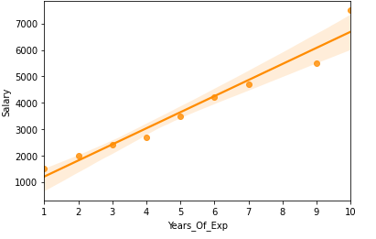

Let’s learn how to find the best fit line.

# Equation of Straight Line

y=mx+c

m →slope  
c →intercept

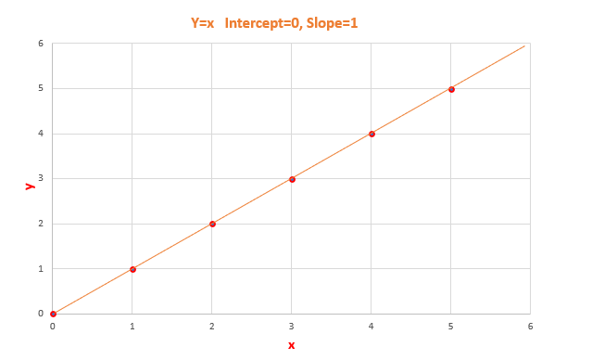

y=x [Slope=1, Intercept=0] -Image by Author

# Model Coefficient

Slope **m** and Intercept **c**are model coefficient/model parameters/regression coefficients.

## Slope →m

Slope basically says how steep the line is. The slope is calculated by a change in y divided by a change in x

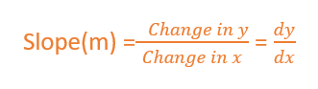

The slope will be negative if one increases and the other one decreases.  
The slope will be positive if x increases and y increases.

*The value of slope will range from -∞ to + ∞.*

[Since we didn’t normalize the value, the slope will depend on units. So, it can take any value from -∞ to + ∞]

## Intercept → c

The value of y when x is 0.  
When the straight line passes through the origin intercept is 0.

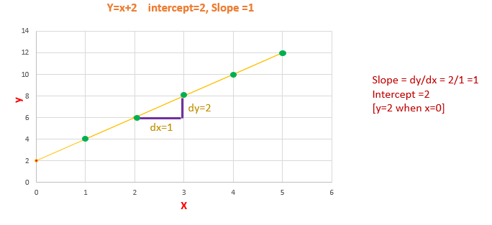

Calculating Slope and Intercept [ Image by Author]

The slope will remain constant for a line. We can calculate the slope by taking any two points in the straight line, by using the formula dy/dx.

# Line of Best Fit

The Linear Regression model have to find the line of best fit.

We know the equation of a line is y=mx+c. There are infinite m and c possibilities, which one to chose?

Out of all possible lines, how to find the best fit line?

The line of best fit is calculated by using the cost function — Least Sum of Squares of Errors.

The line of best fit will have the least sum of squares error.

**What is Linear Regression?**

*Linear Regression is a predictive algorithm which provides a Linear relationship between***Prediction***(Call it***‘Y’***) and****Input****(Call is***‘X’***).*

As we know from the basic maths that if we plot an **‘X’,’Y’** graph, a linear relationship will always come up with a straight line. For example, if we plot the graph of these values

(Input) X = 1,2,3,4,5  
(Prediction) Y = 1,2,3,4,5

## Equation of Straight Line from 2 Points

The equation of a straight line is written using the y = mx + b, where m is the slope (Gradient) and b is y-intercept (where the line crosses the Y axis).

Once we get the equation of a straight line from 2 points in space in y = mx + b format, we can use the same equation to predict the points at different values of x which result in a straight line.

In this formula, m is the slope and b is y-intercept.

*Linear regression is a way to predict the 'Y' values for unknown values of Input 'X' like 1.5, 0.4, 3.6, 5.7 and even for -1, -5, 10 etc.*

Let’s take a real world example to demonstrate the usage of linear regression and usage of Least Square Method to reduce the errors

## Linear Regression with Real World Example

Let’s take a real world example of the price of agricultural products and how it varies based on the location its sold. The price will be low when bought directly from farmers and high when brought from the downtown area.

Given this dataset, we can predict the price of the product in intermediate locations

*When a dataset is used for predictions, it’s also called as Training Data Set*

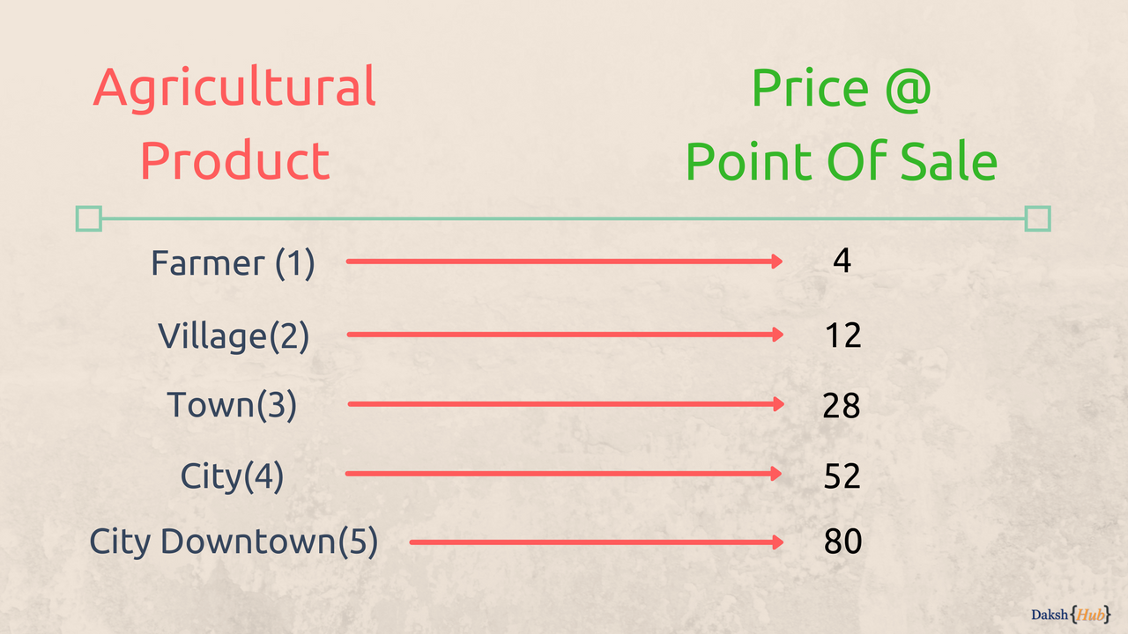

Agricultural Product and its price at point of sale

In this example, if we consider Input 'X — Axis' as Sale Location and 'Y — Axis' as Price (think of any currency you’re familiar with), we can plot the graph as

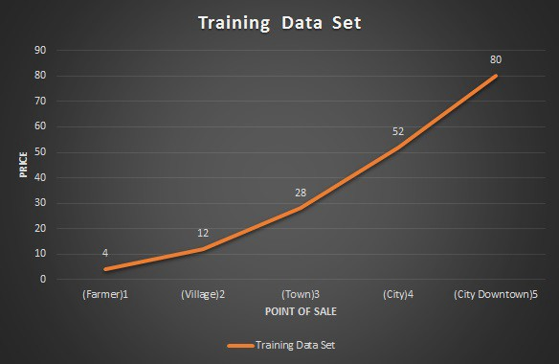

Graph: Agricultural Product and its price at point of sale

## Problem Statement

*Given this dataset, predict the price of agricultural product, if it’s sold in intermediate locations between farmers house and city downtown*

## Training DataSet

The dataset provided above can be considered as Training DataSet for the problem statement stated above, If we consider these inputs as Training Data for the model, we can use that model to predict the price at locations between

* Farmers home — Village
* Village — Town
* Town — City
* City — City Downtown

Our aim is to come with a straight line which minimizes the error between training data and our prediction model when we draw the line using the equation of straight line.

## Equation of Straight Line (y = mx + b)

The maths allow us to get a straight line between any two (x,y) points in two dimensional graph. For this example, let’s consider farmers home and price as starting point and city downtown as ending point.

The coordinates of the start and end points will be

(x1,y1) = (1, 4)   
(x2,y2) = (5, 80)

*where x represents the location and y represent the price.*

The first step is to come up with a formula in the form of y = mx + b where x is a known value and y is the predicted value.

To calculate the Prediction y for any Input value x we have two unknowns, the m = slope(Gradient) and b = y-intercept(also called bias)

## Slope (m = Change in y/ Change in x)

The slope of the line is calculated as the change in y divided by change in x, so the calculation will look like

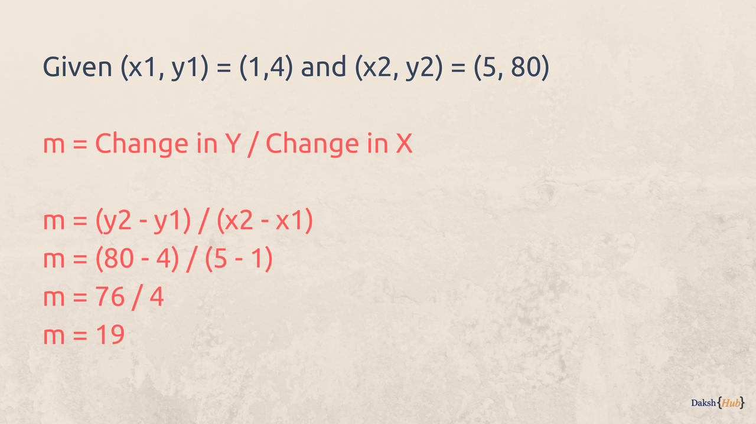

Calculating m = Change in Y / Change in X

The y-intercept / bias shall be calculated using the formula

y-y1 = m(x-x1)

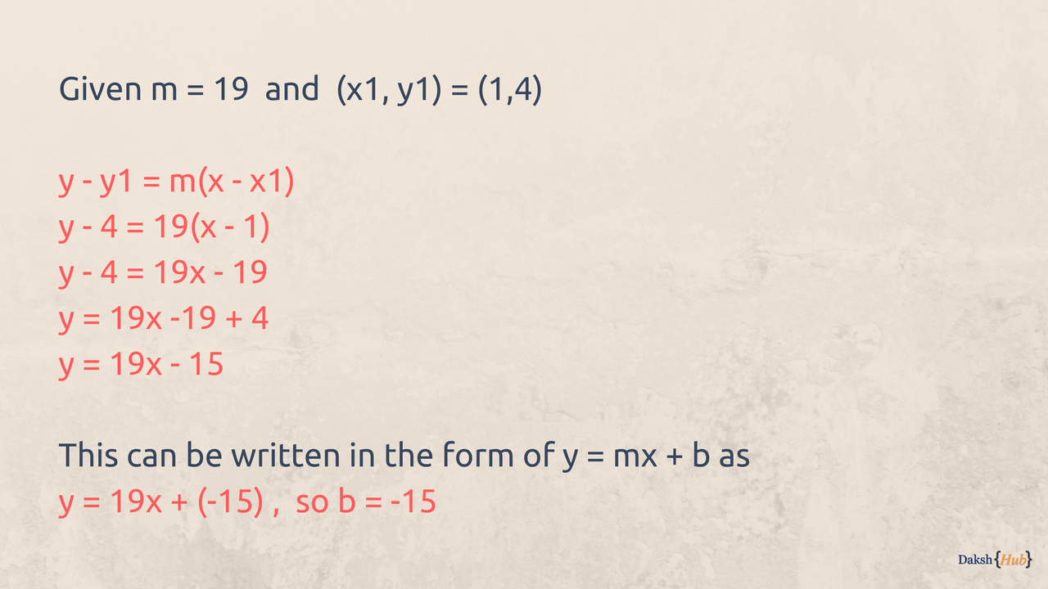

Finding y = mx + b

Once we arrived at our formula, we can verify the same by substituting x for both starting and ending points which were used to calculate the formula as it should provide the same y value.

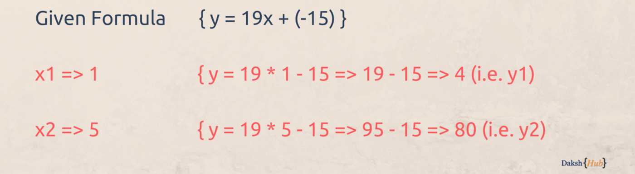

Verifying y = mx + b

Now we know that our formula is correct as we get the same y value by substituting the x value, but what about other values of x in between i.e 2,3,4 , let’s find out

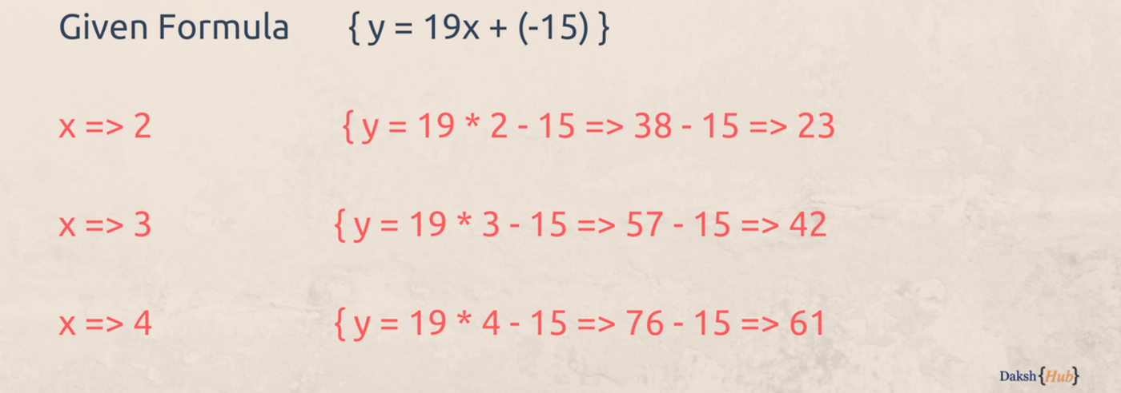

Predicting Y values for unknown X values

These values are different from what was actually there in the training set (understandably as original graph was not a straight line), and if we plot this(x,y) graph against the original graph, the straight line will be way off the original points in the graph of x=2,3, and 4.

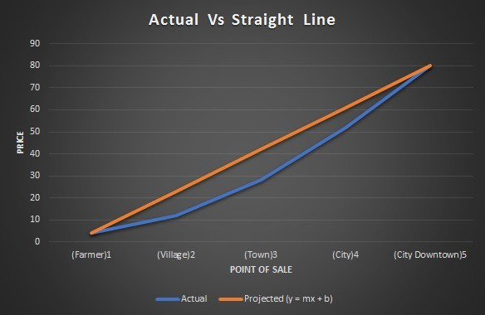

Graph: Actual Line Vs Projected Straight Line

*Nevertheless, the first step is successful as we managed to predict the Y for unknown values of X*

## Finding the error between actual line and regression line

## 

## 

## Formula to find the difference between actual and reg. line.

## 

## Required data:

## 

## X axis data points

## Y axis data points

## Regression line data points

## Numbers of observation

## Data applied to the formula:

## 

## Multiple Linear regression model

## What is multiple linear regression?

## when we have multiple independent variables and we want to find the dependent variable value then we are using multiple linear regression.

## Formula:

## Y = mx + b – when independent variable = 1

## Where,

## w = value of m (slope)

## w0 = value of b (intercept)

## F(x1 , x2) = w1 * x1 + w0 – when independent variable = 2

## F(x1 , x2 , x3) = w0 + w1*x1 + w2*x2 + w3*x3 – when independent variable = 3

## F(x1 , x2 , x3 … xn) = w0 + w1*x1 + w2*x2 + w3*x3 … wn*xn – when we have n numbers of independent variables.

## How does linear regression works

## Where we have line equation: y = mx + b

## We have

## X = 1 2 3

## Y = 3 2 4

## So our SSE formula will be,

## Formula: Sigma(mx+b (predicted value) + y’(actual value) square

## 

## Linear regression Gradient descent

## Gradient descent: To find the loss of actual values and predicted values we are using gradient descent

## NOTE: For one variable we are using SSE and MSE to find the loss function

## Gradient descent formula : Xnew = X – learning rate * dy/dx

## Xnew = New value to x near to x coordinate.

## X = value of X

## Learning rate = approx. number, should not be much greater and lesser try to find the moderate number as per the graph values.

## Dy/dx = nX raise to n-1

## Linear regression model-1

## Diabetes dataset

## Diabetes dataset

## ----------------

## Ten baseline variables, age, sex, body mass index, average blood

## pressure, and six blood serum measurements were obtained for each of n =

## 442 diabetes patients, as well as the response of interest, a

## quantitative measure of disease progression one year after baseline.

## **Data Set Characteristics:**

## :Number of Instances: 442

## :Number of Attributes: First 10 columns are numeric predictive values

## :Target: Column 11 is a quantitative measure of disease progression one year after baseline

## :Attribute Information:

## - age age in years

## - sex

## - bmi body mass index

## - bp average blood pressure

## - s1 tc, total serum cholesterol

## - s2 ldl, low-density lipoproteins

## - s3 hdl, high-density lipoproteins

## - s4 tch, total cholesterol / HDL

## - s5 ltg, possibly log of serum triglycerides level

## - s6 glu, blood sugar level

## Note: Each of these 10 feature variables have been mean centered and scaled by the standard deviation times `n_samples` (i.e. the sum of squares of each column totals 1).

## Source URL:

## https://www4.stat.ncsu.edu/~boos/var.select/diabetes.html

## For more information see:

## Bradley Efron, Trevor Hastie, Iain Johnstone and Robert Tibshirani (2004) "Least Angle Regression," Annals of Statistics (with discussion), 407-499.

## (https://web.stanford.edu/~hastie/Papers/LARS/LeastAngle_2002.pdf)

## 

## 

## Classification in machine learning

## Classification: It is classification between objects where as per the given situation or given data points our model will classify the label (object)

## Working of classifier:

## DATA 🡪 CLASSIFIER 🡪 TRAINED CLASSIFIER

## NEW FEATURES 🡪 TRAINED CLASSIFIER 🡪 LABELS

## Working principle

## KNN classifier for supervised learning

## For example: We want to find whether the email is spam or ham, now we are giving features for the spam mail, and our expected labels will be like this whether our email is spam or ham, now we are giving two features 1) Urgency 2) Talks about money.

## Now as per this features our classifier model will take a look at urgency and talk about money, at it will find out how many percent our mail is talking or contain content about urgency and talk about money, suppose in my email my classifier will detect 56% urgency and 70% talks about money so as per these two values our classifier will plot this point in graph after plotting the this point in the graph our classifier will trace the line between the spam mail data points and ham mail data points, now as per this new data point our classifier will check the position of a data point if our data point is inside of the spam mail boundary that point will consider as spam if our data point is found in the boundary of ham mail data points It will consider as ham mail.

## Classification Algorithm in Machine Learning - Javatpoint

## Fig. example 1

## Working principal

## KNN classifier for unsupervised learning

## KNN Classification Tutorial using Sklearn Python | DataCamp

## Working principal of classifier where the millions of data points are given to us and we are plotting on that points on to the graph, now we are giving another new data point and we are looking for the label of that particular point.

## Suppose we have point in between spam points and ham points as shown in example 1. We have multiple features and data points we have millions of data points now we are looking for label of our new data points, now our classifier has the value of K, where suppose we have value of K = 3,

## (NOTE: The value of k = number of nearest data points will be countered by the model.)

## now our classifier start making circle around the new data point and counter the previous data points and give them a number suppose we have k = 3 so our model will counter 3 nearest points. After countering the 3 nearest data points it will find the distance between the new data point to previous data points nearest one will be denoted as 1st then 2nd 3rd and so on, for distance formula:

## d=√[(x2-x1)^2+(y2-y1)^2]

## (NOTE: Distance formula depends upon the number of features for 3 features distance formula will be: d=√[(x2-x1)^2+(y2-y1)^2+(Z2-Z1)^2] and so on to the n number of features)

## after finding the distance formula model will check the label of that point whether that point is ham or spam, suppose 1st is spam, now it will check the label for 2nd point now this point is ham again it will check the point the 3rd point now suppose this point is ham, so as per this result, where model found 1 spam point and other 2 points as ham so our depend upon this result our new data point will be considered as ham, because we found 2 majority ham near data points.

## Overfitting underfitting

## Overfitting: When we have data points, and when we are dealing with training data, as you know we want less, loss error to decrease this loss error we are fitting our best regression line on the training data points and we are getting zero or very less loss error. Suppose we have two function f(x) and g(x). f(x) is trying to give us the best data points with less loss function that is magic function and g(x) is user, user trying to give testing data to as same as training data so we can find less loss function. We are trying to approximate the data points values in overfitting

## Overfitting has less, loss error in training data. But It has high loss error in testing data. Because the training data is not fitting on the place of training data.

## Overfitting and Methods of Addressing it - CFA, FRM, and Actuarial Exams Study Notes

## Methods of overfitting:

## Resampling: When user has 1000 data points and user have decided to grab 700 data points for training and 300 datapoints for testing. Now user is picking up the data randomly k number of times where the value of k is random, so for training and plotting on the graph, after the graph has plotted user trying fit the best line on those random data points so it will get a better result in testing time.

## Holding a validation: Now we have data with 1000 datapoints, now user just have decided to bring 700 datapoints for training and remaining 300 for testing. Now holding a validation means from our testing data we are taking bunch of data points like 100 and we are verifying with these data whether my model is overfitting it self or not, if our model has overfitted with the best line, user will change the logic or trying to implement their program.

## Underfitting: Underfitting is the simplest thing when we are not able to plot our best line on the graph and we are getting high loss error in training and testing both the data. Means we are underfitting our best line on the graph and we need to change the calculation or logic to fit the best line on the graph correspond to those data points so user can get less loss error.

## Machine learning Krish naik

## AI vs ML vs DL vs DS

## Artificial intelligence: Ai application is able to do any task by itself without the intervention of the human from any side ai will think and take decision by itself and perform the tasks according to the taken decision.

## For ex:

## The recommendation on videos which you are watching on the Netflix it understands you’re watching interest and showing the recommendation of new videos it is works by ai. Without asking you anything

## If the user is buying the iphone so the recommendation of the headphone on your website it could be possible because of ai engines.

## Self-driving cars they are considering the roads as an input and taking the decision to drive a car on road It could be possible by ai engines.

## Machine learning: Inside any ai there will be the part of the machine learning model which is working as stats tools to analyse the data, visualize the data, predict the outputs and forecasting statistic will be the major part inside the machine learning

## Deep learning: Deep learning it is trying to mimic the human networks where how the humans are learning by itself the goal is for deep learning to learn the machine itself and It could be possible with multi layered neural networks. It is a sub set of machine learning where based of the multi layered neural network will help your to train your ai or any kind of model.

## Machine learning & Deep learning

## Supervised Machine learning

## Regression problem

## Classification

## Unsupervised machine learning

## Clustering

## Dimensionality reduction

## Supervised ML

## When the features are given to the particular model let us consider the age and weight so suppose we have couple of data where

## AGE Weight

## 24 62

## 25 63

## 21 72

## 27 62

## This is the given data based on this particular data we want to create one model where we give the age and it will predict the weight

## In this particular example there are two types of features the first on is

## independent features: In this case the independent feature will be the age of the person because we are changing this input values and the changes will be seen in the output

## Dependent features: weight will be the dependent feature where the weight will become an output and when the age of the person means where the independent features will change its value the dependent value (output values) will be changed.

## Regression & Classification

## Regression

## AGE Weight (o/p variable)

## 24 62

## 25 63

## 21 72

## 27 62

## Continues variable have seen in the problem it will be consider as a regression problem where the scatter plot will be made to predict the future upcoming values, in this case the output will be an continues variable.

## Classification

## When we have fixed number of output category it will be considered as a classification problem

## For ex.

## No of study hours 🡪 No of play hours 🡪 No of sleep 🡪 output Pass/Fail

## Where we have two fixed output category those are pass and fail so it will be considered as classification model problem.

## If the we have two fixed categories of output so it, will we can call as Binary classification

## If we have more than two fixed categories output it will we can call as Multi class classification

## Unsupervised Machine Learning

## Clustering: It is a grouping algorithm which is used the group the number of values, The independent features will be given to us and there will be no dependent features where there will be no output variables this clustering is used to group the number of things

## For ex: The company is launching the product

## Product 1🡪 Is for rich

## Product 2🡪 Is for middle class

## So based on the clustering it will cluster (make the group of people) and it will cluster the two types of people the rich and the middle class based on that customer segment strategy the rich will be seen different ads and the middle-class people will be seen different types of ads based.

## Each cluster will be provided with the different type of facilities or features. Based on the requirement

## Dimensionality Reduction: Where we have thousand of features and we need to convert those features into the lower dimensional features it means we are trying to reduce the number of features and we make it those features to hundred features it will we can call as dimensionality reduction. PCA, LCA Algo. Will be used.

## Linear regression:

## Formula of best fit line:

## Hypothesis of (x): h theta (x) = theta 0 +theta 1 * (x)

## Theta 0 🡪 Intercept

## Theta 1 🡪 Slope

## Unless and until we don’t get the best fit line, we need to change the value of that0 and theta1.

## 

## NOTE: To get the best fit line in graph we need to keep changes the values of theta0 (intercept) and theta1 (slope) after updating the theta0 and theta1 value we need to apply the cost function which is shown below now if you are getting the minimal value, it means that is the best fit line on your graph

## Cost function/squared error function formula:

## h theta (x)🡪 Predicted values

## y 🡪 Actual values

## 

## Cost function is the distance between the predicted value (h theta (x)) and actual value which is (y) if we apply the summation of all the data points using cost function it should b the minimal if we are getting the minimal answer after applying the cost function it means that the plotted line is the best fit for our data points.

## 

## Cost function 2.

## 1/2m 🡪 it will help us to find the average of all the summation of data points it will help us in derivation with respect to (x) the formula of derivation of n which is shown below.

## 

## What we need to solve the minimal values of all the data points which is squared error function as shown below.

## 

## For ex 1: Consider the following points (1,1) (2,2) (3,3) plot these points onto graph and find the best fit line by applying hypothesis of x formula and cost function formula.

## 

## Image 1: hypothesis of x where theta 0 = 0 theta1 = 1

## multiplying the theta1 value with all the unit points of x After multiplying that our predicted points will be on

## theta1 * x = 1 *1 = 1 pred point 1

## theta1 * x = 1 *2 = 2 pred point 2

## theta1 * x = 1 *3 = 3 pred point 3

## 

## Image 2: cost function

## After that we are just subtracting the value of pred point – actual value

## Where,

## h theta (x) 🡪 pred point

## y 🡪 actual value

## after putting the values of pred point and actual values subtract those two values as and apply square on that do this for all the other points and finally add those numbers.

## ½ * m where m 🡪 number of data points

## ½*3 🡪 1/6 * [0]

## Final answer is 0 in this particular case. Where it is the minimal number, we can say that the line which is plotted on graph that is the best fit line for all the data points.

## Convergence Algorithm

## This algorithm is helping us to reach to the global minima by applying the formula, in the case When we are finding a theta1 to get the global minima but after sum iteration (2 or 3) we need to find out the best global minima point which should be less in cost function graph so we can say that, that is the perfect global minima which will give us best fit line.

## 

## After applying that formula we need to find out the derivative of the theta1 after by the formula f’(x) = 2x after getting the derivative we need to equate this equation. After that we will get our global minima.

## 

## As if our global minima are decreasing, we need to subtract the theta1’s derivative value will be negative and then we apply that with convergence formula. And if it is increasing then the value of theta1 will be positive. As shown below.

## 

## Gradient descent algorithm

## Here our convergence formula will take us to the global minima of the respective curve but if we have curves in wave form then we could get stuck in local minima so to get rid of the local minima we are using gradient descent algorithm.

## 

## As the same process will be followed which is followed in convergence formula as shown above.

Derivative formula of any point as shown below. 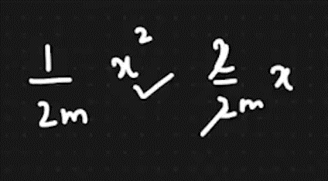

## We need to find the derivative of the given theta1 and theat0’s value as shown above where my theta1 and theta0’s will be 0 or 1 so as same as the J’s value will be 0 or 1 J is nothing but it is the cost function. As shown below we will equate the equation.

## 

## Performance Matrices

## R square

## Adjusted R square

## R square

It is used to check that how good is my model there are Sum of resudual and sum of total are there. Where as per the below formula we are subracting the distance between predicted point to acualt point

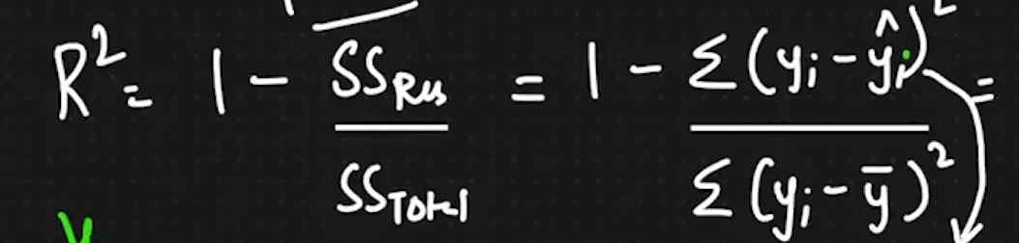

Where

yi hat 🡪 h theta(x)

yi 🡪 actual point

y bar 🡪 Mean

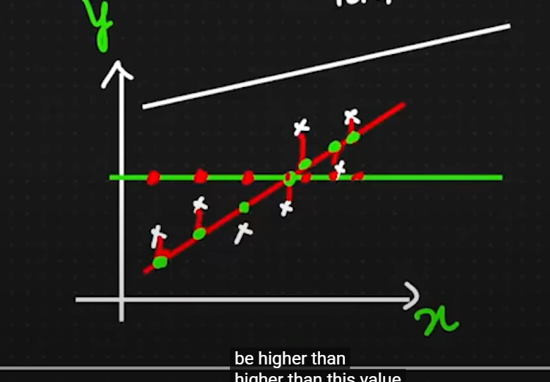

As after applying the formula the numarator will be a low number where the denomenator will be a high number and then we are diving that perticular number and subtract with one we will get one positive number

As shown below if the numarator is high and denomenetor will low then the result will be a negative number

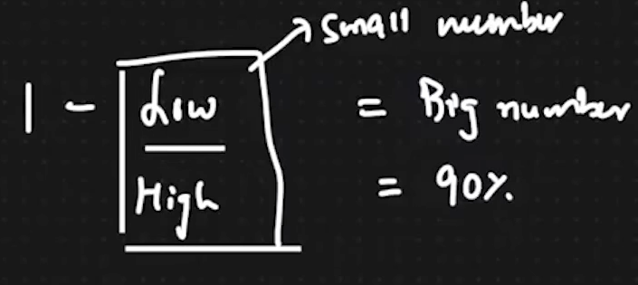

For example:

We are taking one example where the house price will be our dependent feature and the Location , Bedroom and gender will be our Independent feature now after applying the formula without added the gender feature we are getting the R square value 90% because the location and bedrooms are highly co related to the house price after adding the gender the R square value 91% because the gender is not co related to the price of the house so **If the independent feature is highly co related to the dependent feature our R square value will increase tremendously.**

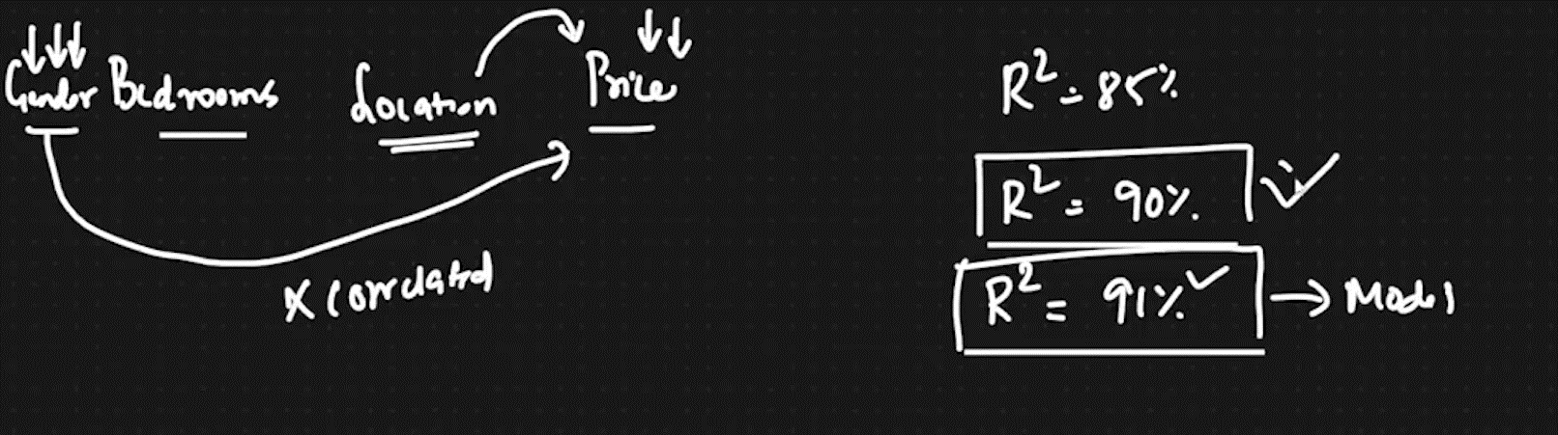

**Adjusted R square**

It is used to adjust our R square with the features.

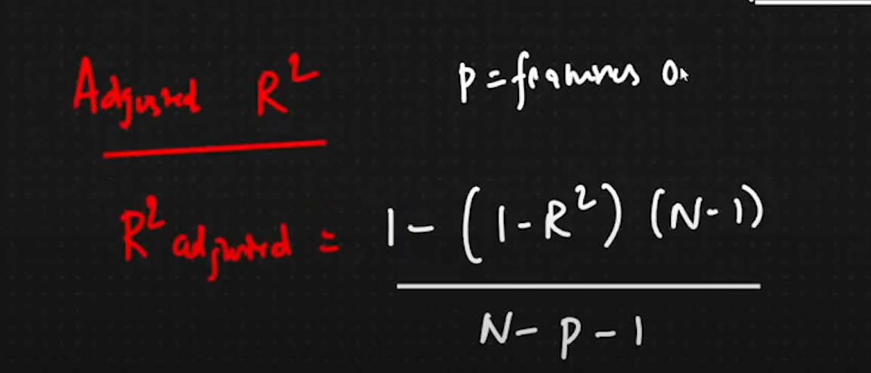

P 🡪 No. of features

N 🡪 No. of Data points

Now here we are applying the formula and putting the values of each and everything we will the our adjusted R2 value is increasing or decreasing based of the P’s value because if no of feature will high it will subtract with N and 1 and it will become small number. This is the reason where the R2 is increases and the Adjusted R2 is decreases because of the number of features.

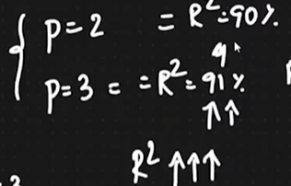

**Ridge and Lasso regression**

In this particular regression we are just going to learn about Ridge and lasso regression before looking into it we are just clearing like what is the overfitting and underfitting and what is a generalized model of a particular machine learning model

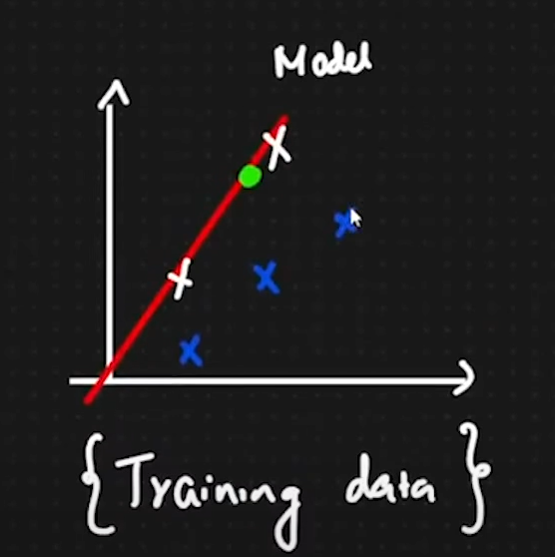

In machine learning model when our training data on machine learning model but the testing data is not working properly on a machine learning model this situation we can define as overfitting model where our testing data or training data both are not working properly on a model

**Overfitting:** If our training data is working properly on an overfitting model that particular situation we can be called as **low bias** if our testing data is not working on a particular model on a particular machine learning model so it will become a **high variance**

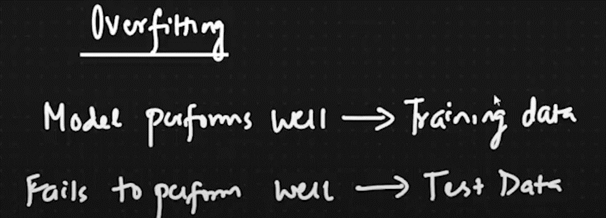

**Underfitting:** Where training data and testing data both are not working properly on our machine learning model so that particular situation we can called as a underfitting where the training data we can call as a **high bias** and the testing data they can call as **high variance**

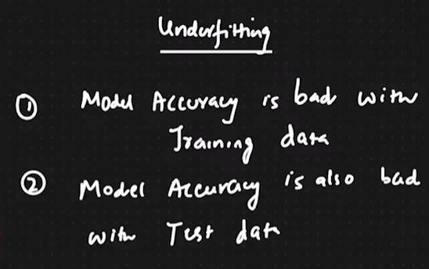

**Generalize form Model**: if the training and testing data both are working properly and giving us the expected predicted points so that particular model we can consider as a generalized form model.

For example: consider the below image with three different types of models.

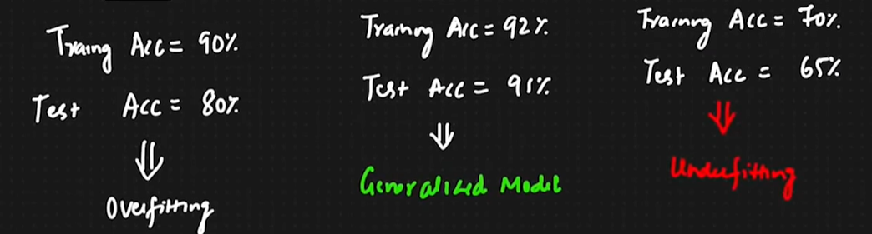

**What ridge function does?**

Ridge function is adding one parameter which is called as Lambda multiply with the slope square in our cost function

To get rid of this particular overfitting situation we are just trying and we are just applying the rich regression on to our model so our model will not be over fitted.

Consider this below picture

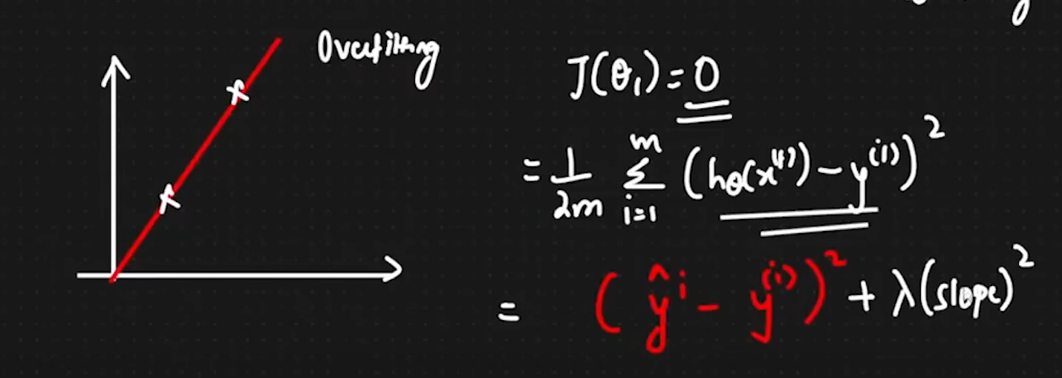

As shown above picture our two data points which are aware training data points as we have just considered the J of theta 1 = 0 also we are applying our cost function just considering h theta of x equals to Y hat.

How the Ridge regression algorithm is working?

Considered that we are having the two training data points which is perfectly best to fit a best fit line, new data points giving us the actual predicted value so called that you get the best fit LINE which will pass through predicted value we just need to change or we just need to keep updating the theatre one’s value by using the formula of Ridge regression algorithm

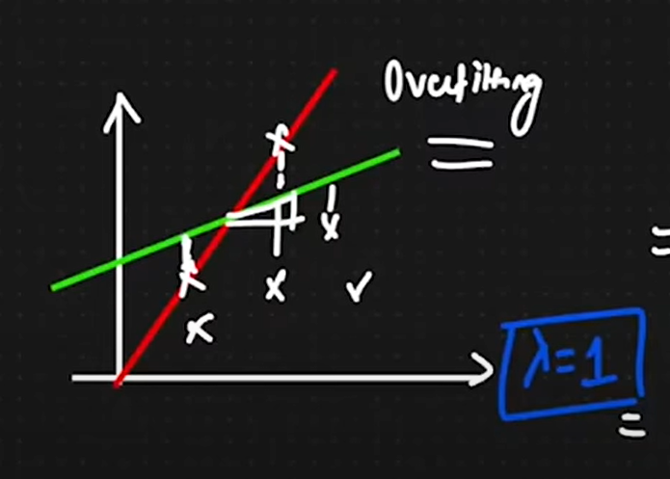

I am considering as the above shown picture I am considering the two training data points and the line is passes through these two data points where I am just adding new data points and again I am just trying to pass the best fit line through all these testing data points, get the best fit which is passing through all the related points I am just applying the formula ridge regression.

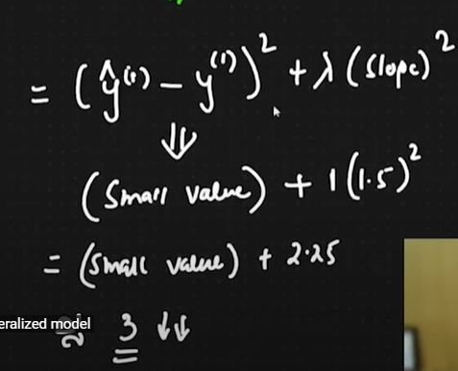

For example, consider this above picture where I am applying my cost function when I am just subtracting the predicted value minus actual value multiplying with the slope square I am considering the Lambda is equals to 1 and I am also considering the theta one’s value which is one, of Lambda and slope with our cost function where I am just adding the theta 1 with cost function and multiplying with lambda variable and squaring the value of theta 1 and then I am getting my value which is approx. 3 as shown in above picture.

Lambda which we can call as hyperparameter where this lambda variable will tell us how fast will happenlesser and higher the steepness of the theta1. Where slope should not be steep

**Lasso regression:** This lasso regression is helping us in feature selection we will see ahead.

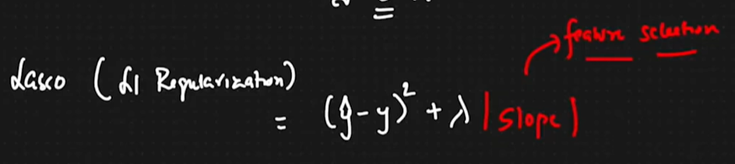

As consider we are having too many features and we are just finding the slope of all the feature where all the thata0 that1 theta2 … theta n and whichever the theta value (feature) is not probably playing the huge role in this model that particular feature’s value will be very small and that feature can be neglected.

By applying the lasso regression It will help us to prevent the best fit line as well as it is helping to select our features.

Applying both the ridge and lasso regression we are just trying to find the best fit line and what ever is giving us the prefect matrices (R and adjusted R) we are using that particular model.

Ridge regression:

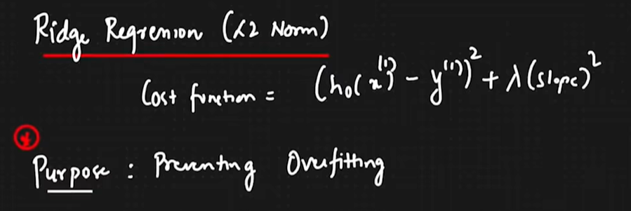

Lasso regression:

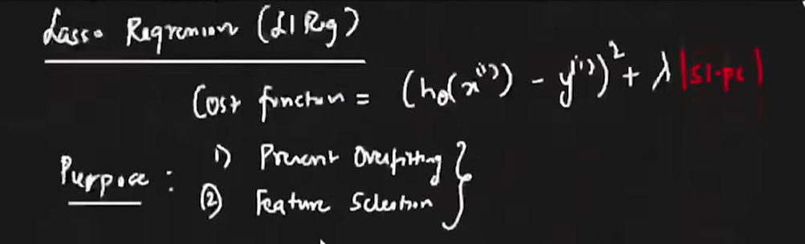

Assumption for linear regression

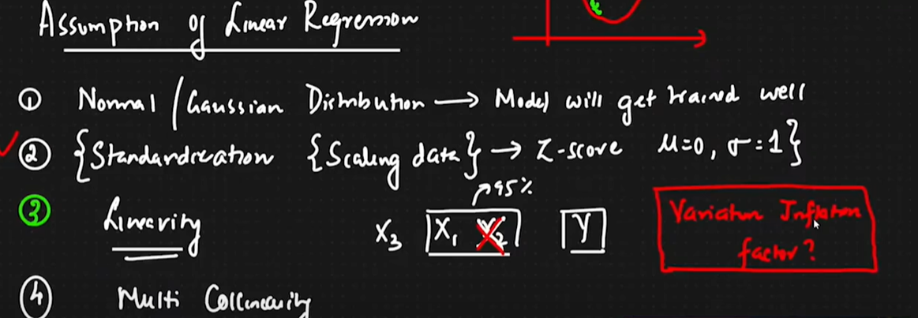

**Logistic regression Algo. (Classification)**

When the outcome result, we will get in two ways Yes/No this is we can called as binary classification and here we are using this logistic regression to perform this binary classification. As well as here we are taking the some part of linear regression where we are creating the best fit line and simply squashing that line and there will be middle point between 0 to 1 so if the point lies on above middle point that is true if the point lies below middle point that will be false simple.

Formula which we are going to use🡪 sigmoid formula, g(z) , linear cost function, logistic cost function, performance matrices, confusion matrices.

Consider the below logistic regression graph

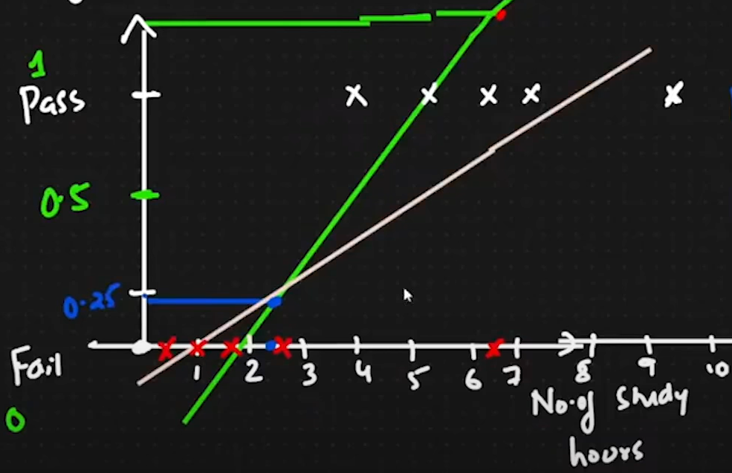

In above graph we are having one middle point which is 0.5 and the No. of study hours and the outcome which will be out Y’s value now as we have plotted some points in red and white colour and we are passing the best fit line and the and then we are squashing that line and if new point in blue colour lie somewhere below 5 hours so that would be give us the false result as shown in graph.

To squash the line, we are using the sigmoid activation function as shown below.

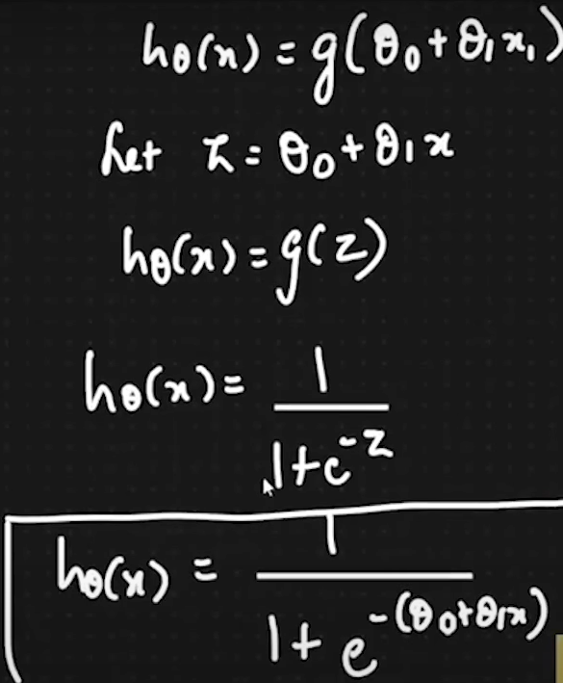

After squashing the graph will look something like this,

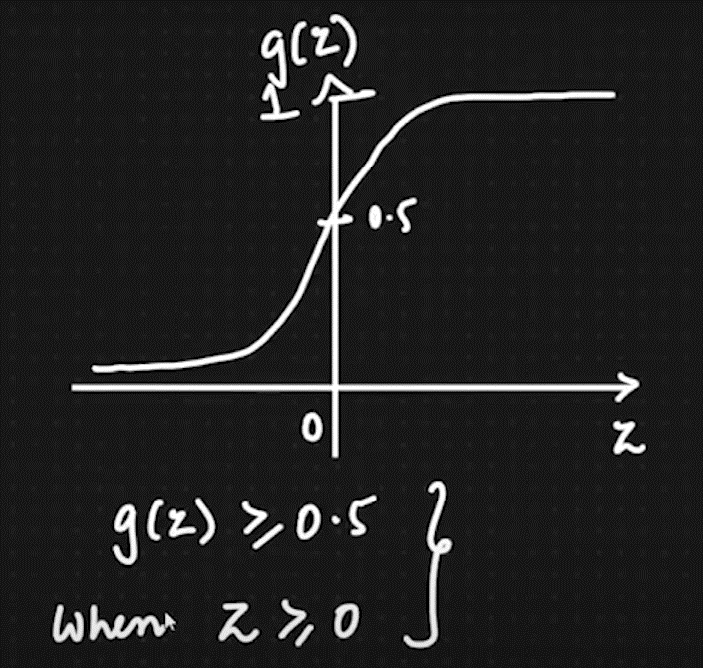

After the squashing we are applying the cost function of logistic regression see we are using the linear regression cost function to get the best fit line but we are using the logistic cost function to get the value of y whether it is 0 or 1.

Consider the below dataset.

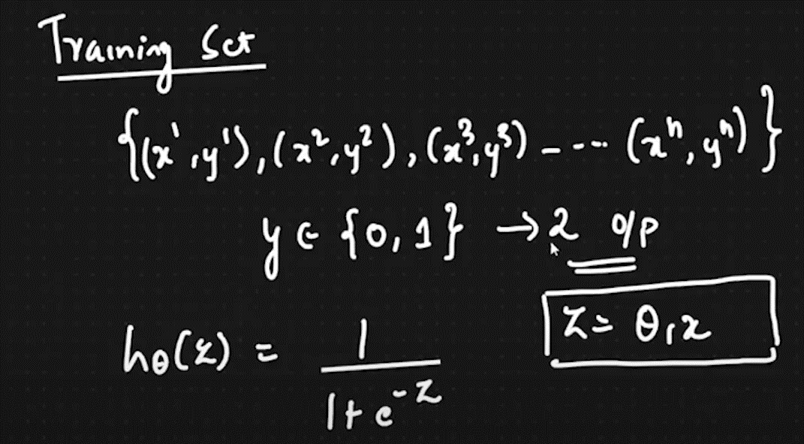

Here we are taking numbers of datapoints x1 x2 x3…xN and then we are expecting the result in the manner of 0 and 1 where our hypothesis function will be h theta of z where the z is one divided by 1 + e raised to minus z.

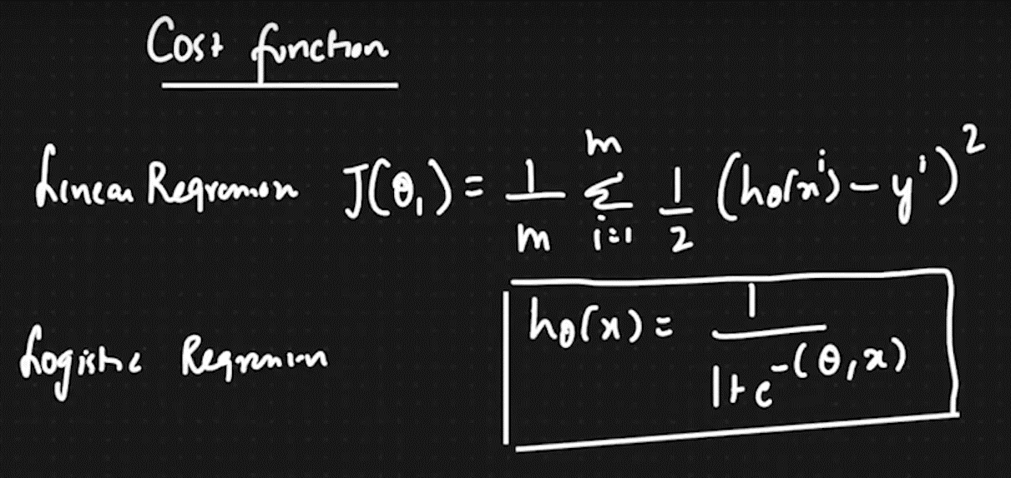

Linear regression cost function as we have seen to get the best fit line,

And logistic regression cost function to get the predicted value but we cannot use this logistic function because it is non convex function so it may lead to us towards the local minima as shown in below graph

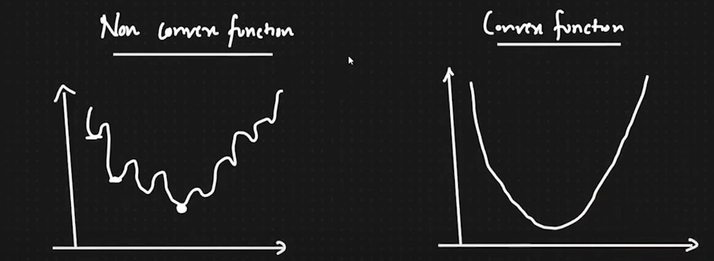

Convex and non-convex graph

So the solution to do not get stuck in local minima while using the logistic regression cost function we are using the cost function in different way as shown in below picture.

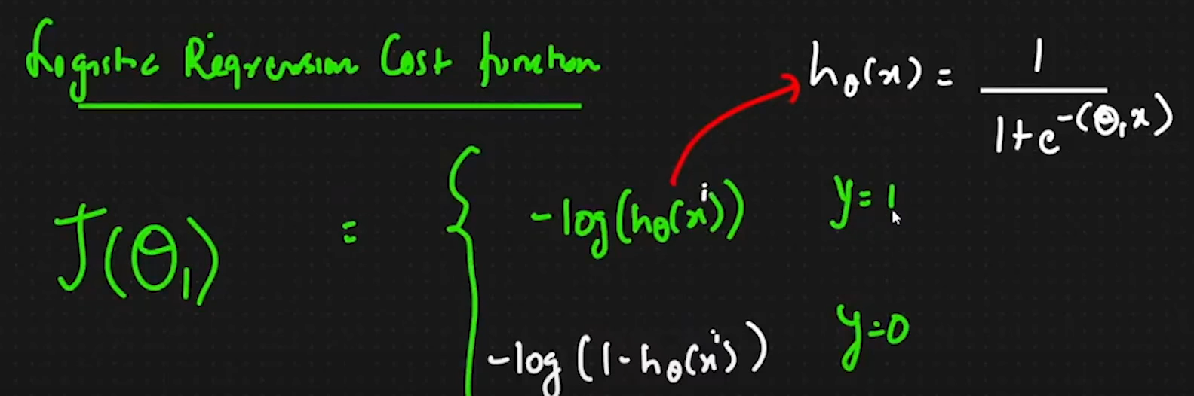

In this case as we have let the theta0 as 0 at this time and we are considering the theta1 value now by using that cost function as shown above we will predict the value of J(theta1).

As to use the cost function with respect Y=1 our graph will be as shown below

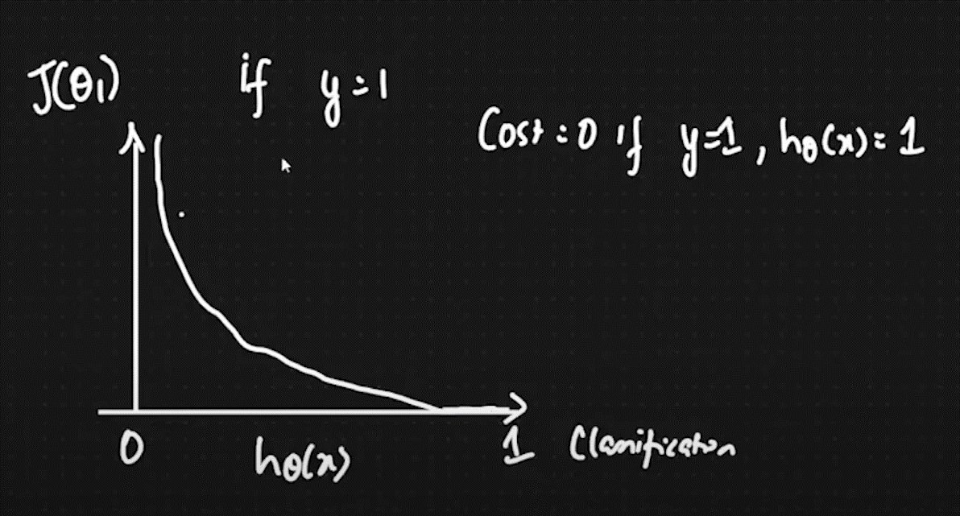

As to use the cost function with respect Y=0 our graph will be as shown below

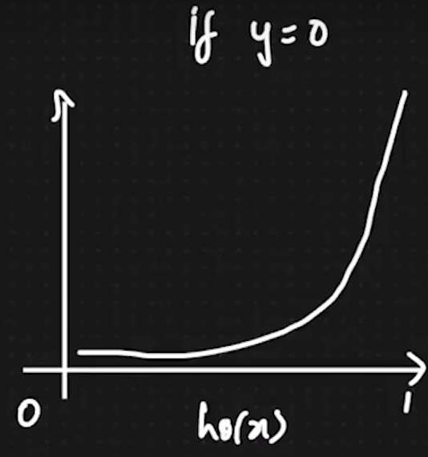

If we combine both the functions which are for Y=1 and 0 so our function will be something like this,

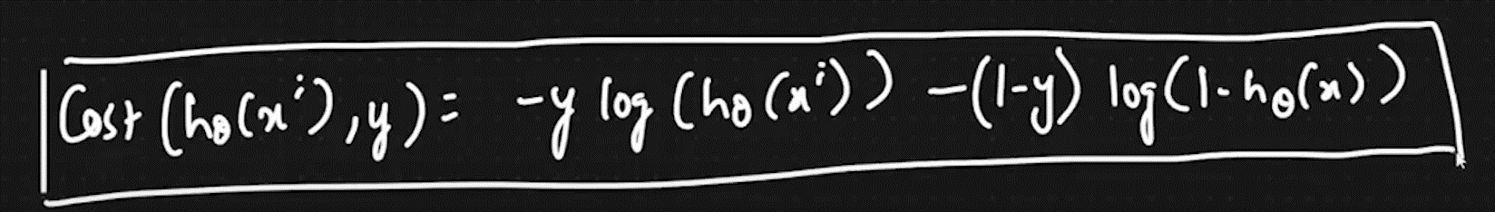

After to solve the value of jtheta1 we are using the cost function as shown below where our h theta of x is nothing but the function g(z) as shown above in sigmoid function picture.

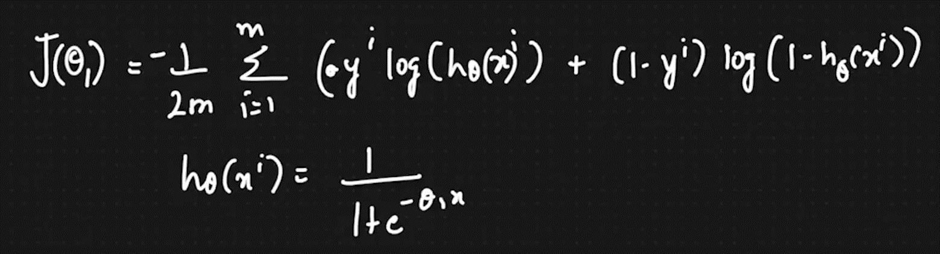

After that we need to apply our convergence formula as we learned in linear regression and we are using that until we will get our solution.

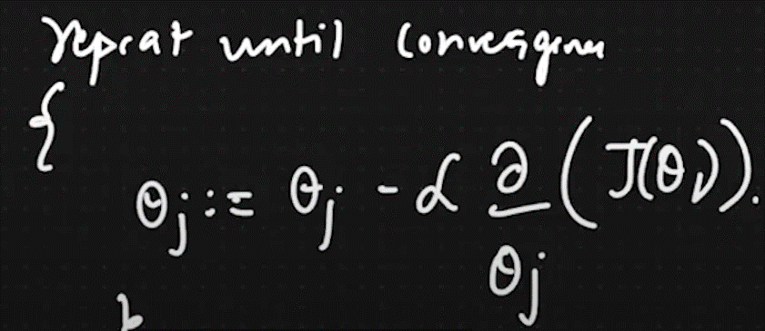

**Performance metrices**

It is used to check how good our machine learning model is it is based on the confusion matrix where we are just comparing the actual value and predicted value and based on that we are counting the True Positive(1,1), True Negative(0,0), False Positive(0.1) and False negative(1,0) values and then we are applying the formulas.

The performance matrix example:

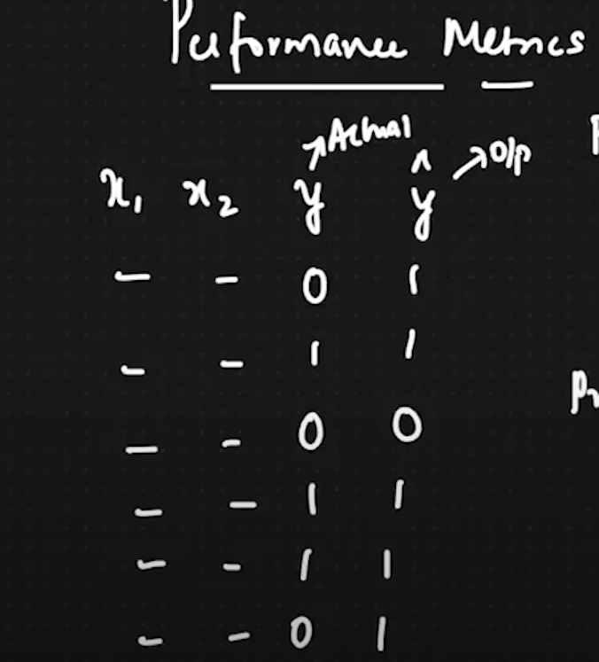

Confusion matrix will be as shown below:

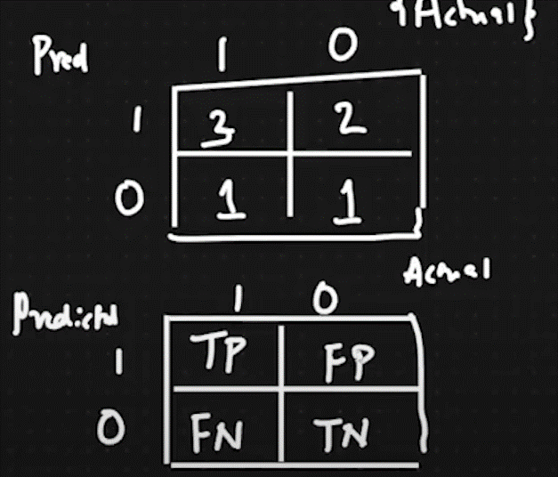

As shown above the confusion matrix is divided into 4 parts as mentioned above the True positive (1,1), True Negative (0,0), False positive (0,1) and False negative (1,0). And we are comparing the actual value and predicted value and we are incrementing as the values will be, if actual is 1 and predicted is 1 we will increment by 1 in confusion matrix as vice versa with other values.

Now to check the accuracy based on the confusion matrix we have on formula and equation is pasted below:

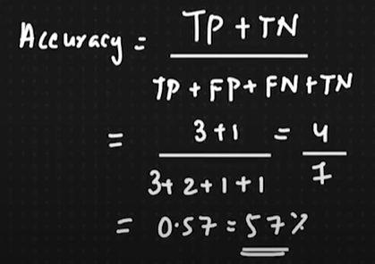

Our model aim is always should to reduce the values of false positive and false negative so we will get the more correct answer if our model is giving us a greater number of true negative and true positive it means that we are getting accurate results by the model our model is not predicting the wrong. If we are getting the greater number of false negative and false positive it means that we need to reduce the number of both of these things so we can get the better accuracy model.

**Balanced and imbalanced dataset**

Another thing which we need to take a look on that and that is our model should not be trained with biased data, the meaning of biased data means on training data we are having 900🡪 data which will give us answer 0 and 100🡪 which will give us the result as 1. As shown below

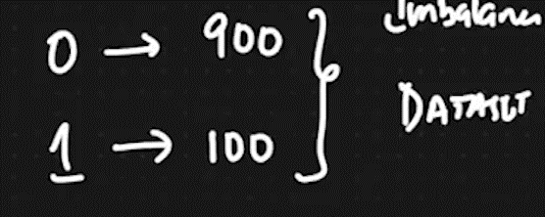

As if we have 600 datapoints which is giving us the 0 as results and 400 datapoints which is giving us the 1 as result so that will become a balanced dataset where there is no many huge differences in this data point’s results so our model can train itself very well

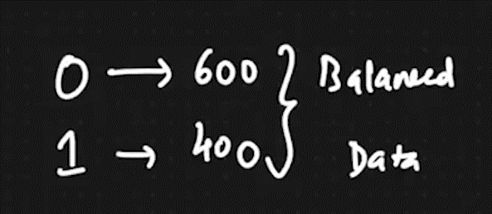

Another thing in this imbalanced data we can get the better accuracy but in this case most of the time our model might be predict 0 as we have greater number of 0 result’s datapoints in our model so we should not always be dependent on the accuracy we also should take a look on the data is balanced or not. We always choose the balanced data in our model and if we are getting good accuracy in that particular model so it means that we are having good logistic classification model.

The terminology which we are using where we are having imbalanced data there are three terminologies which are Precision, Recall and F-score.

Recall Terminology

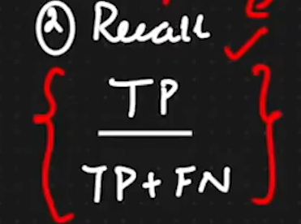

As per the formula recall says that out of all the true positives how many of that predicted correctly.

Precision Terminology

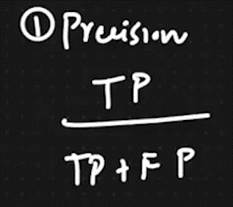

As per the formula recall says that out of all the positives how many of them are predicted true and positive.

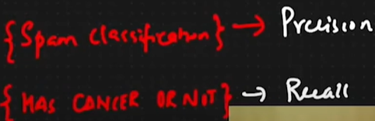

Consider the above cases where the first one is span classification and the second one is having cancer or not now in spam classification, we are using precision because we are considering that we are not getting the spam email but the model is predicting that the email which we got that is a spam so that will be wrong prediction where in this case it is okay to get wrong predicted. But in cancer the person has cancer and if our model is predicting that the person has no cancer so that will be an big issue so that’s why we are using recall over there where person has cancer and it is predicting that he does not have cancer so might be can go to doctor and he can get his result as he has cancer, we are not using precision because in that case we are considering that person does not have cancer but he has a cancer so as mentioned above that is the big issue that’s why we are using recall where initially we are saying that yes you have cancer so person can go to the check-up. And in precision we are consider the thing initially false and then we are predicting as true. In this case we are just reducing the false positive values so we can get better accuracy of model and in recall we are reducing the false negative values so we can predict better. Consider the below confusion matrix.

Red colour 🡪 Recall

Blue colour 🡪Precision

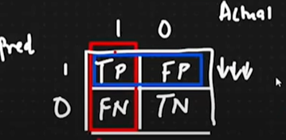

F-score Terminology

When we both false positive and false negative and we need to decrease both of those things at once we are using f score.

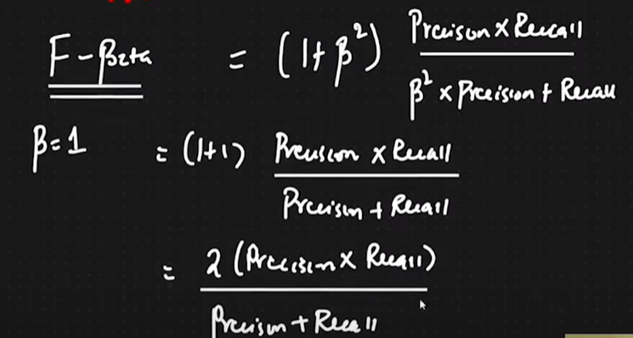

As shown above the f beta means that we are giving importance to both the things false positive and negative and then we are applying the formula as shown above

Where we need both the thing FP and FN we are considering the value of beta = 1. This will we can call as F1 score.

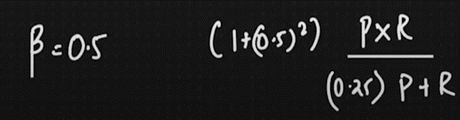

When I am letting the value of beta = 0.5 it means we are more importance to False positive. And then we are applying the formula as shown above. This is we can call as F0.5 score.

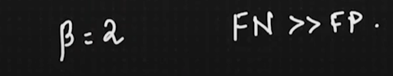

If our beta =2 it means that we are giving more importance of FN than FP. This will become F2 score.

**Naive baye’s Algorithm**

It is a classification problem based of baye’s theorem where are dealing with the data tables. where are finding the probability with respect to probability with yes and no.

We shown below we are using below formula to find out the probability with respect to yes/no where the x term will be our independent features and we are dividing each x term with the value of yes or no’s value. And then we are finding our value with respect yes or no.

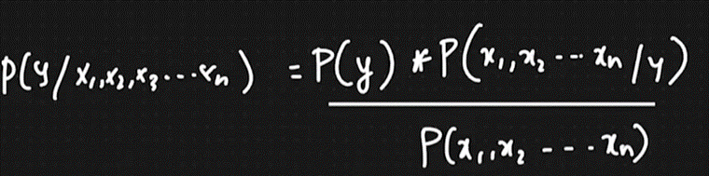

if we simplify the above equation so it will be like as shown below. 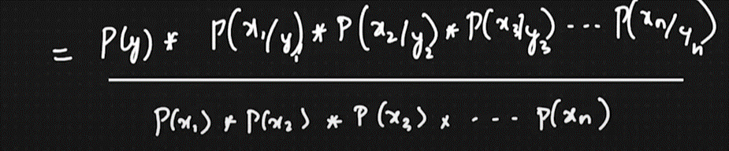

if we want to find the value with respect to yes by taking xi (xi will be our record of one data) and then we are applying the below formula to get the value of xi with respect to yes.

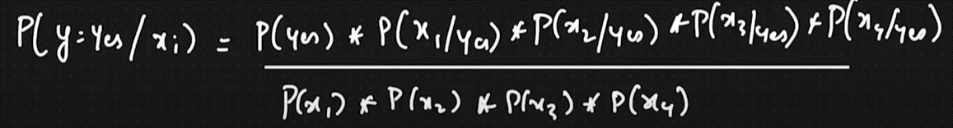

if we want to find the value with respect to no by taking xi (xi will be our record of one data) and then we are applying the below formula to get the value of xi with respect to no.

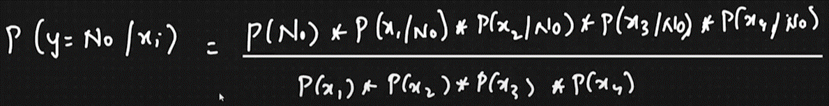

Suppose if we found the probability of yes and we got the value of 0.13 and then we are applying the normalization formula by adding that with 0.05 and then if we are got 0.72 and the we are getting 72%.

And then we are applying the same with probability of no and then it will be 0.28 and then it will be 28%.

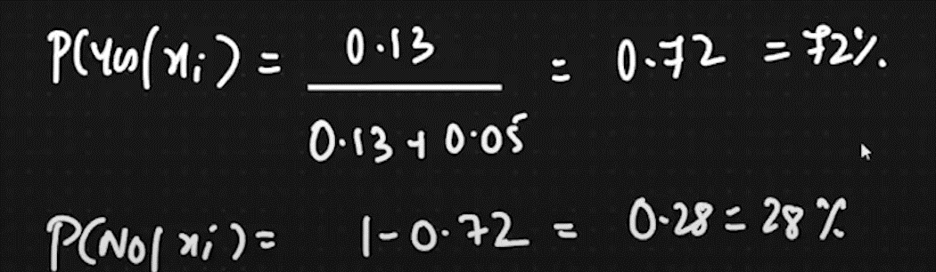

So we are getting the 0.13 with value of yes and as with no we are getting 0.5 so if we are getting the value greater than 0.5 so it will be true and then if it is below than 0.5 it will be false.

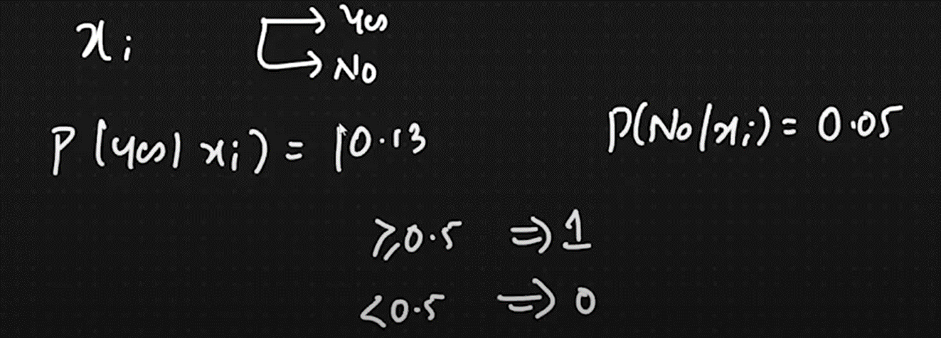

Let us consider below dataset.

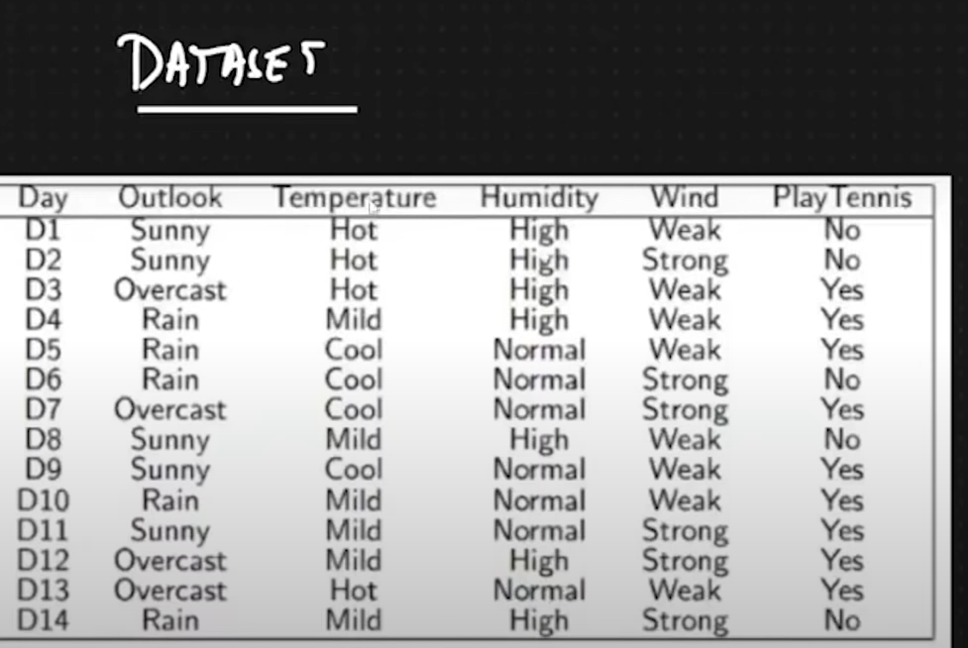

In this above dataset we are having number of columns and then we are just applying the above given formulas and then we are finding the probability of yes and no by taking columns of features.

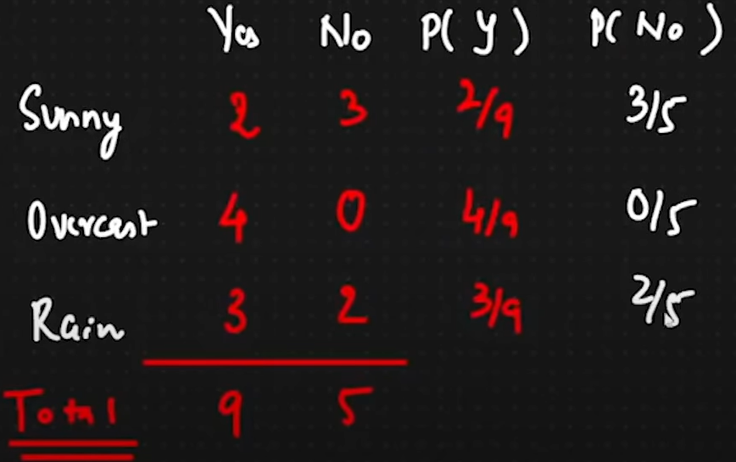

Consider the above columns where we have taken the column of outlook and we are taking the sunny overcast and rain their category will be our independent features. Now are we are finding the how many of them are getting yes and no and as per that we are incrementing the value of particular feature by 1. Now if sunny is getting yes 2 times so it means we are getting sunny as yes you can play that is 2 times and then we are diving that with total no of yes and no.

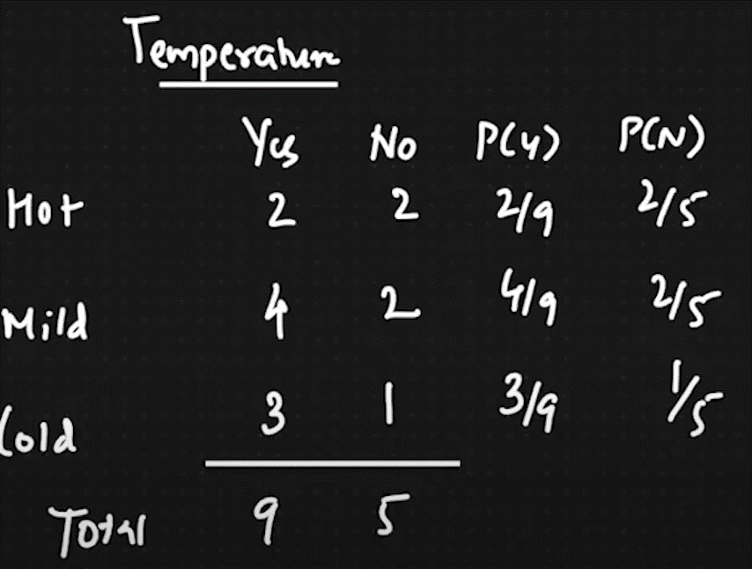

As we have taken another column features and then we are doing the same as we did above.

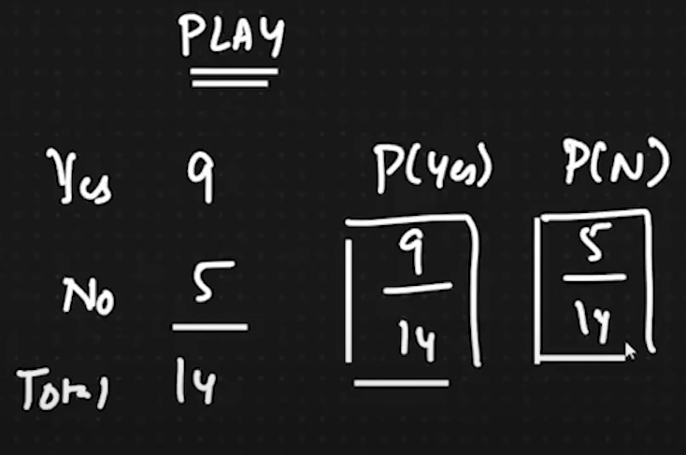

As over here we are adding the value of total number of yes and no in the data set and then we are dividing the actual value with the total number of yes and no.

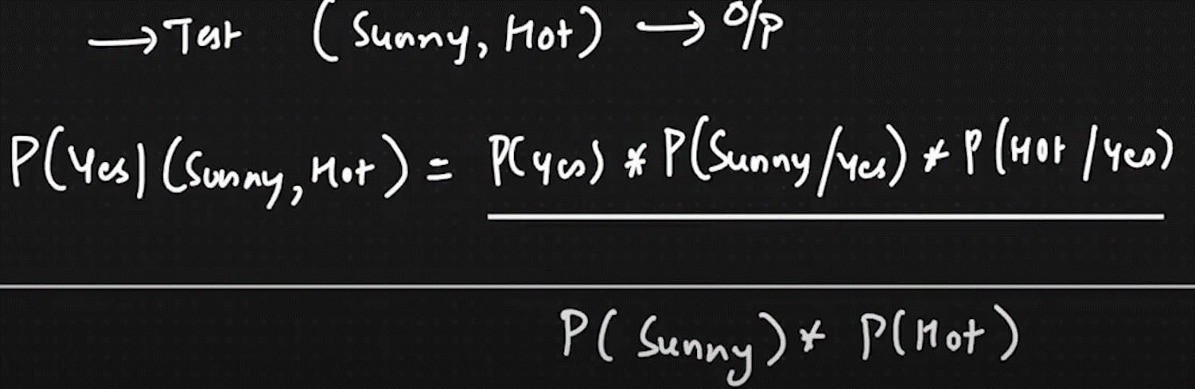

As we are finding the probability for yes the sunny and hot and we are applying values in the formula as shown above.

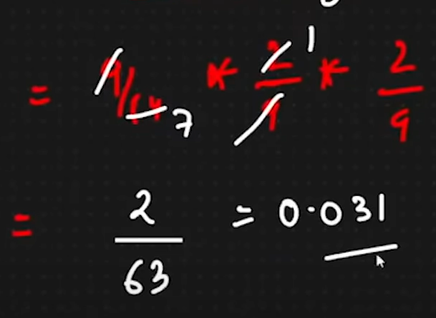

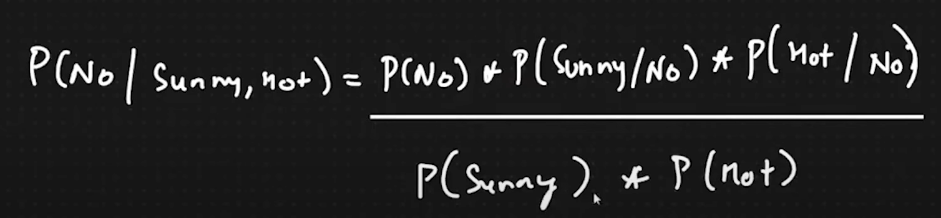

As we are finding the probability for no the sunny and hot and we are applying values in the formula as shown above.

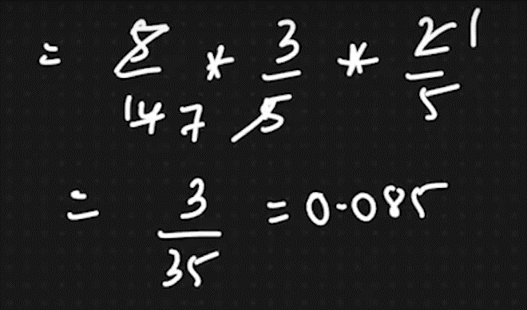

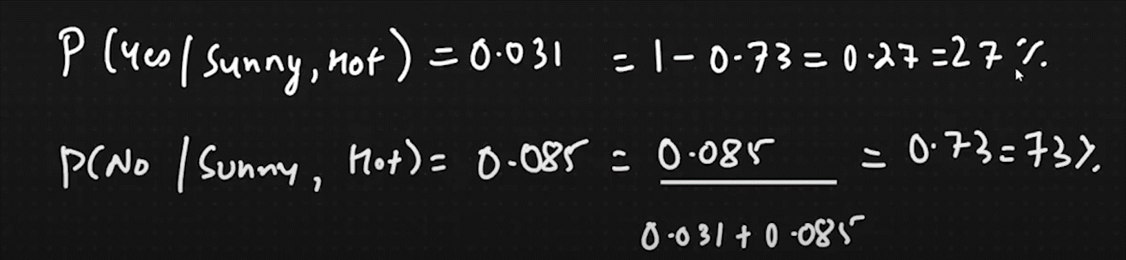

After getting the values we just applying normalize formula and then whichever is giving more than 50% answer that will be our final result in classification algorithm in naïve baye’s.

**KNN Algorithm (Classification, Regression)**

KNN stands for k nearest neighbour it is classification as well as regression algorithm.

First on all we will see the classification problem.

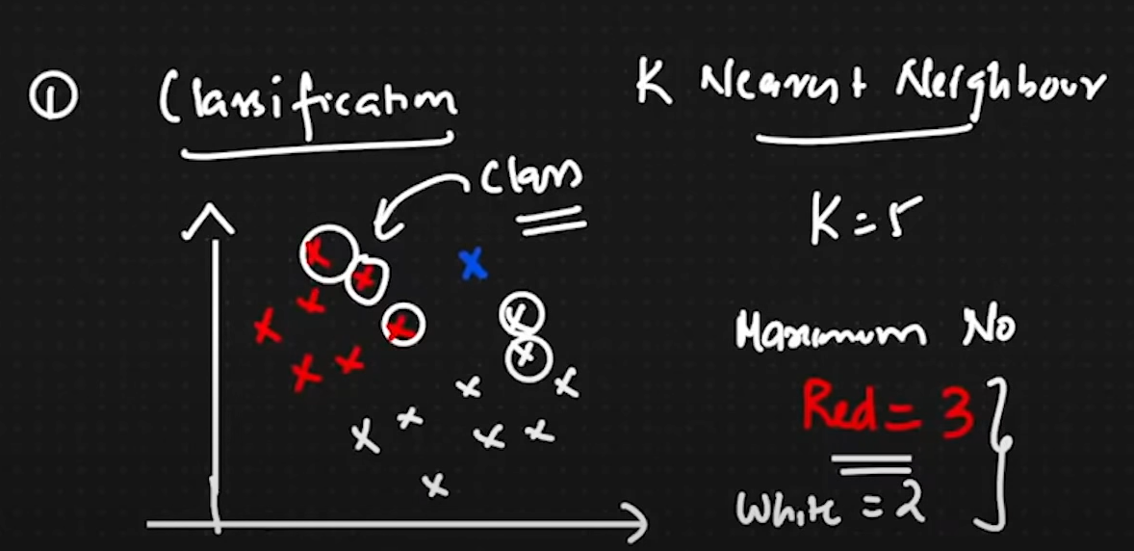

As consider this above picture the red data points are one category

And the white one is another datapoint category now suppose one datapoint lies on somewhere which is in blue now we need to identify that, this particular blue point belongs to which category red or white. So, to figure it out that we are taking the values of K which is our hyperparameter now as you can see the K=5 now based on Manhattan or Euclid’s distance formula we are finding the top 5 nearest data points.

As the value of finding datapoints is equals to the value of k. now in this case we have found red nearest datapoints near to blue and white nearest points near to blue so as we have found red = 3 so that blue datapoint is consider as the category of red.

Euclid’s distance formula

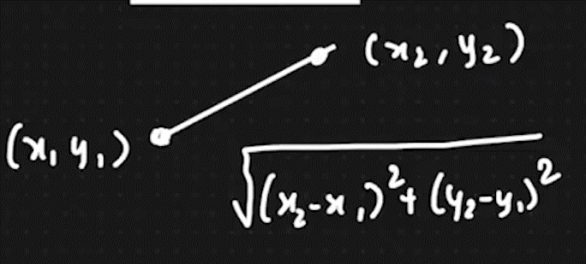

Manhattan distance formula

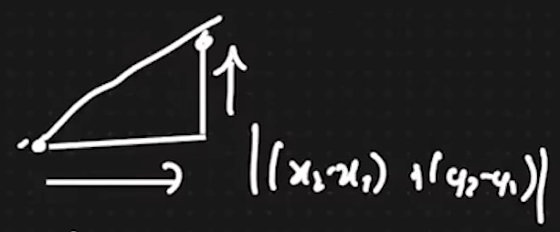

**KNN Regression problem**

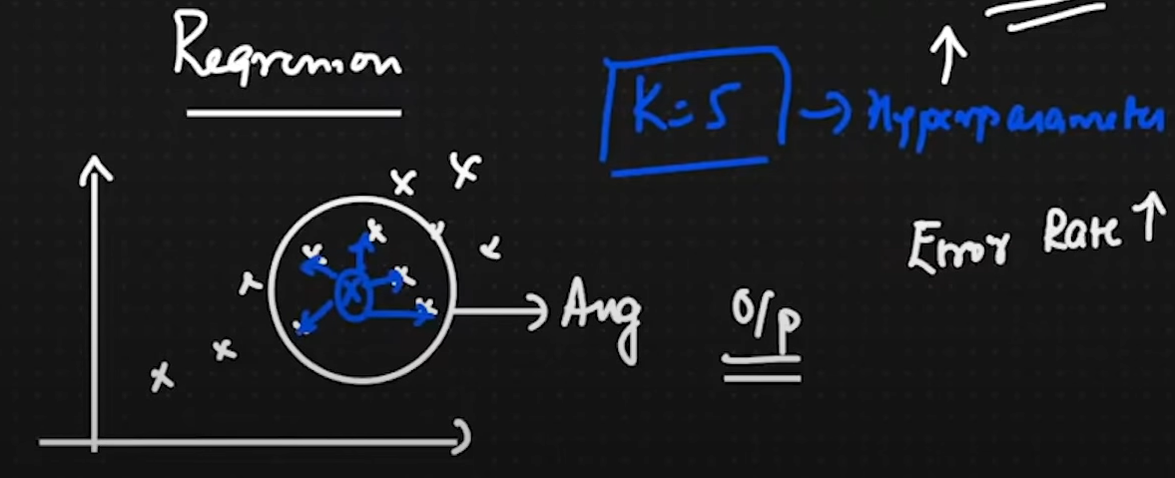

As here we have datapoints right over here in above picture now if new datapoint is coming as per the k’s value it will take out the 5 nearest datapoint and then it will average the all the datapoint’s value and then new prediction value will be lies on that.

We will change the value of K from 1 to 50 and whichever is giving us lowest error rate that model will be picked.

**Decision Tree Classification**

Decision tree classification is used to perform when we need to use if else conditions based on this decision tree classification, we can identify whether which feature or which category is going to give true or false with which category and feature.

Consider this below dataset to understand the decision tree classification.

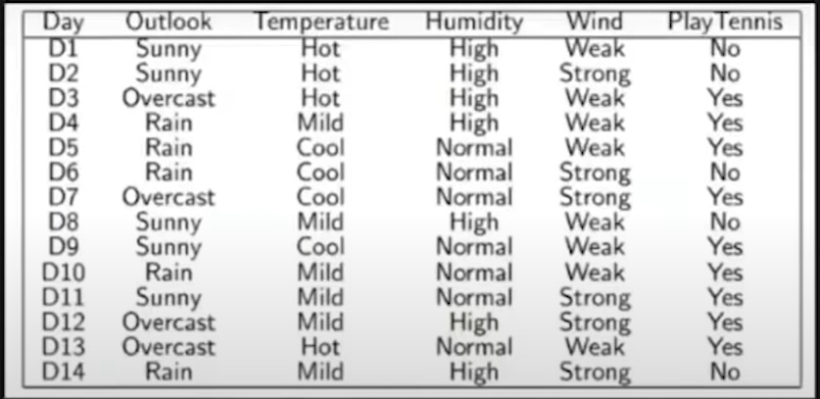

Here consider this below feature tree, this tree is having 1 feature and 3 category.

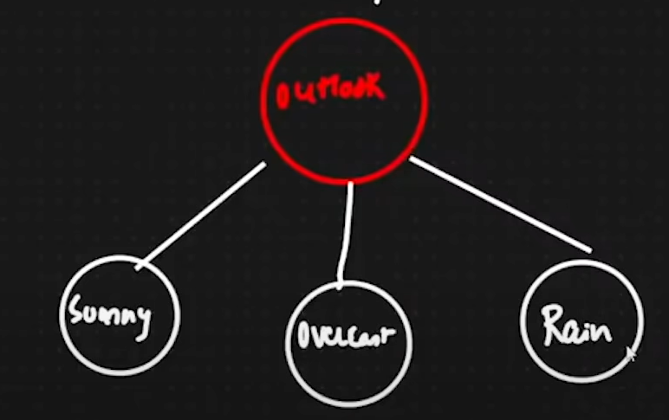

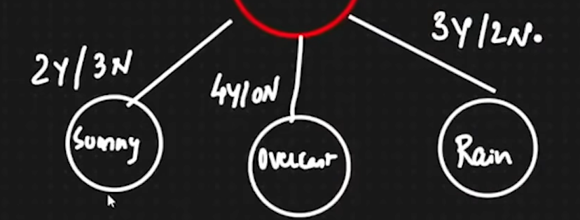

Here as you can see 2 yes and 3 no it means while taking this feature how many yes and No we are getting based on the final result, like how many times I am getting yes and no while taking feature or category.

Now as you can see 2 yes 3 No for sunny, 4 yes and 0 No for overcast and 3 yes and 2 No for rain. That is the probability of the total number of yes and no for particular category from the probability of total number of yes and no of the particular feature.

If we do summation of all the category’s Yes and No it will become the total number of Yes and No of that feature.

Let us talk about pure split and impure split.

Pure Split 🡪 In our category if any node is having the ration of 100% Yes or 100% No that we be a pure leaf node. Where the probability of get yes or no is 100% take example of overcast as shown in above picture it is having 4 Yes and 0 No that will be the ratio of 100% Yes. As same with No. if I am getting this kind of result of category or feature that will be considered as Pure split.

Once we get the pure node, we can stop adding more features and category into that we can stop the further splitting

Impure Split 🡪 In any leaf node is not having pure split means the ration of yes or no is not totally 100% so then it will become an impure node. And then we will start splitting on that node.

Splitting of nodes 🡪 If we are getting pure node we no need to do further split but if we are getting impure split It means we need to add one feature into that node and again we need to add the category and we need to check the possibility of getting yes and no until we don’t get pure node we apply this on particular node. As shown below.

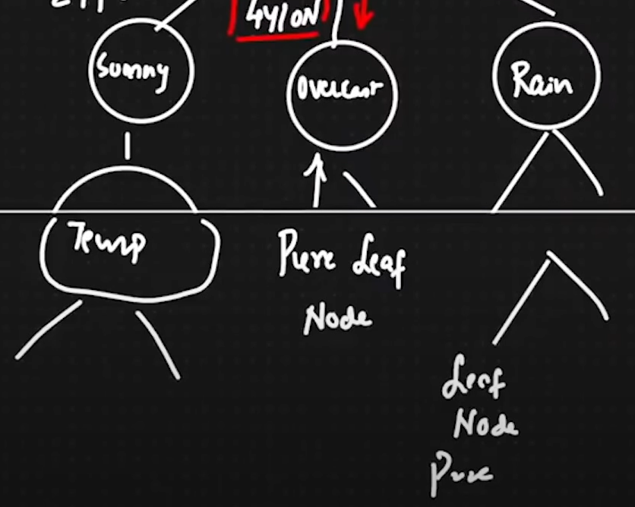

Now the question arises that how we can check the purity of any node and which feature we should take for splitting?

To check the purity of any node we are using entropy and gini coefficient.

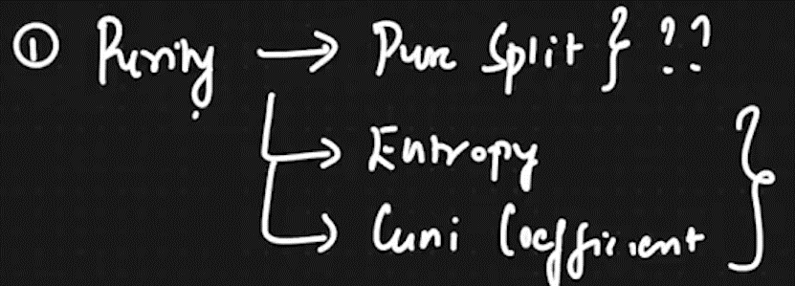

Now, to check whether which feature we should take for splitting we are using Information gain.

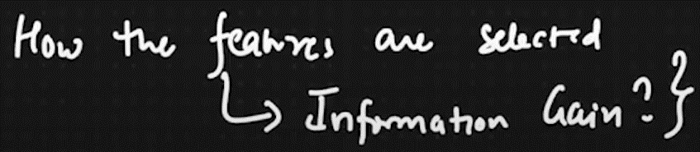

Formula Entropy and gini impurity as shown below

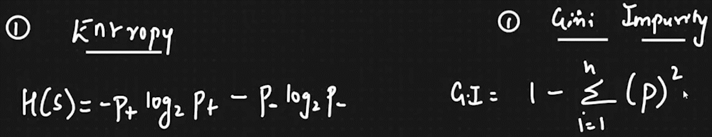

P+ 🡪 Probability of Yes

P- 🡪 Probability of No

Example of Entropy consider this below picture

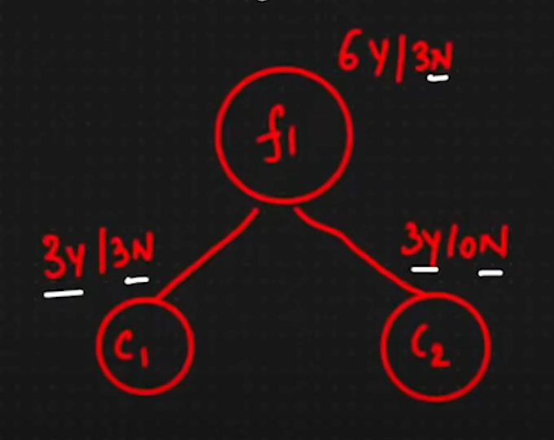

Feature 1 is having 6 Yes and 3 No probability from the final result. Category 1 is having 3 Yes and 3 No and category 2 is having 3 yes and 0 No. Now we will compute the purity of category 1 and 2 based on entropy

We are computing the purity of category 2 just because it is a pure node. Based on the above entropy formula as shown above.

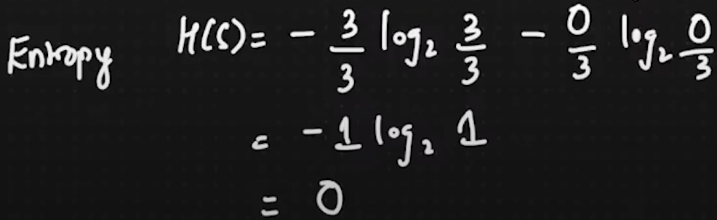

If we are having pure node it means our final answer will be 0. If we are having 0.5 it means 50-50 ration in yes and no so our final answer will be 1.

If we plot the graph of entropy of getting 0 and 1 it will be something like that as shown in below picture.

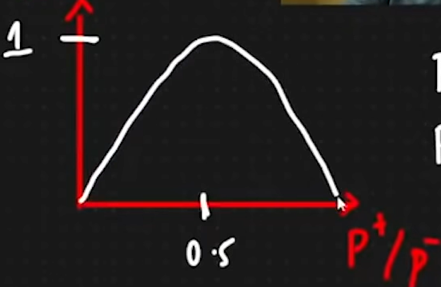

If my P+ is 0.5 so ultimately my P- is also 0.5 and if my P+ is 0 is means I am having all the Yes and 0 No if I am getting P- as 0 it means I am having all the No and 0 Yes in the particular node.

If we compute the purity using entropy of category 1 it will be something like that as shown below.

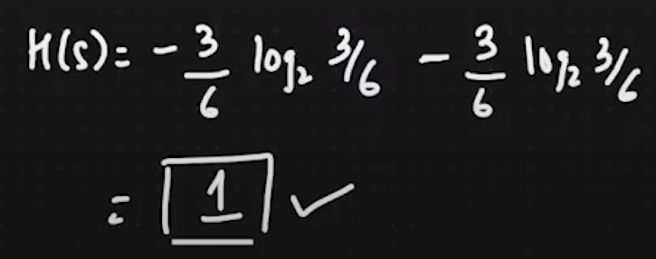

As we are getting 1 as final answer because the ration of yes and no means the ration of P+ and P- is 50-50. So after applying the entropy formula we are getting 1 as final answer.

In entropy we always get the answer in between 0 to 1. If we are getting 0 it means it is the pure node if we are getting answer greater than 0 and less than 1 something like 0.7 ,0.3, 0.6 in this case we will apply another formula which is information gain to take new feature for further splitting of that node. After that we will apply this same process until we will get 0 as answer in purity, if we are getting 0 in answer it means our node is became pure.

Now we are done with entropy we will further see which feature you should select for splitting as we have formula for that which is called as information gain.

For example consider this below picture.

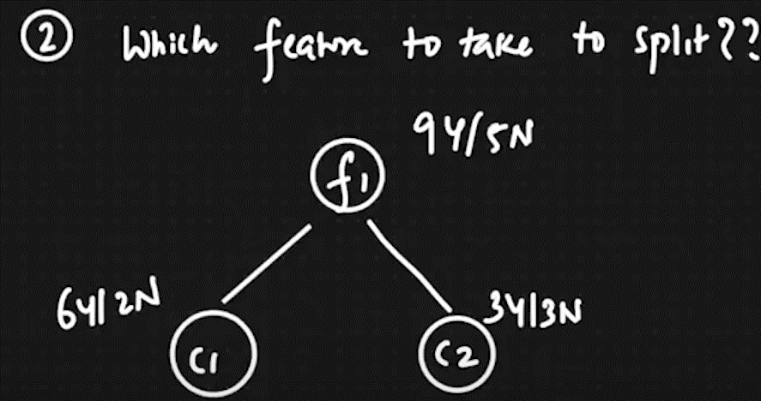

In this above picture as we are not having any kind of pure node to make the node pure we need to do splitting, so which feature we should take for splitting we will figure it out with the help of this below formula.

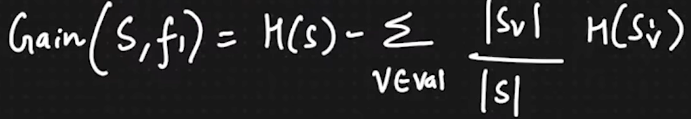

H(s) 🡪 Entropy of particular Feature.

Sv 🡪 total number of category’s sample.

S🡪 total number of feature’s sample.

H(Sv) 🡪 Entropy of particular category.

In our example first of all we will find the H(s) means entropy of feature and then we will find the purity of category 1 and 2 then we will compute further as shown below.

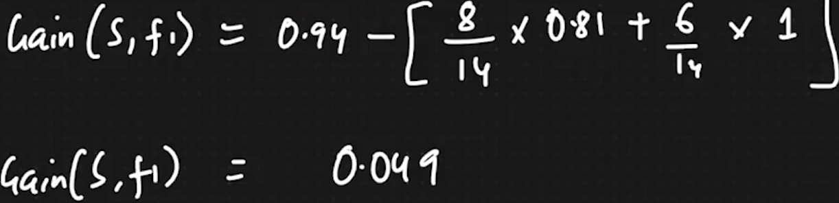

0.94 is purity of feature

0.81 is purity of category 1

1 is purity of category 2

8/14 & 6/14 is Sv/S

And in the final answer we are getting 0.049 whichever feature is giving us higher number that feature will be selected for the splitting.

Now we will take look at Gini coefficient.

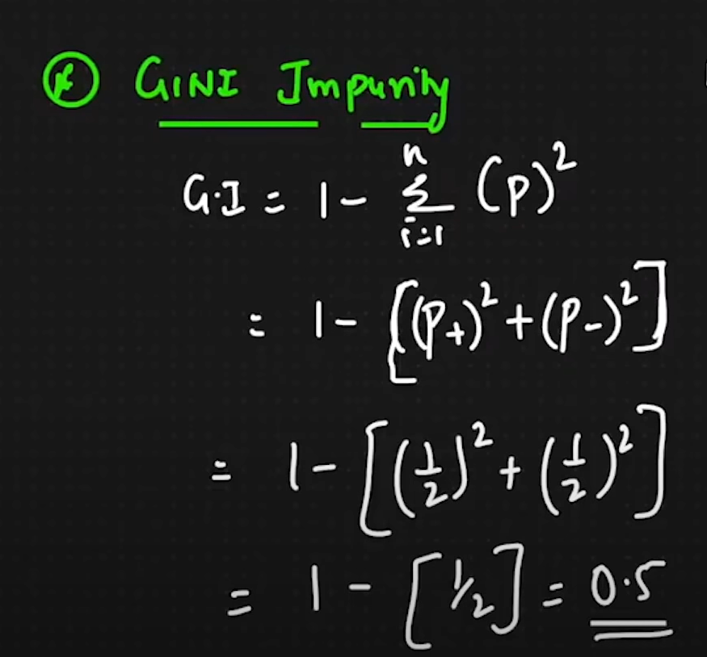

As per its formula you can compute the purity of any node in this case if we are getting 50-50 ration so the gini impurity value will 0.5 in entropy it will be 1. That is difference between gini impurity and entropy.

As we are having time complexity of each and every algorithm, the decision tree is having worst time complexity because we are splitting and testing, we are applying purity split again and again until we will get pure leaf node that’s why it is having worst time complexity.

When to use entropy and when to use gini impurity for pure split of the node?

For this if we are having smaller dataset so we will compute with the entropy and if we are having big dataset then we will go with gini impurity for purity split because gini impurity will take lesser time to compute than entropy. That is how the Decision tree classification algorithm works.

**Decision Tree Regressor**

In this decision tree regressor we are going to solve the problems by reaching to the leaf node with the use of regression technique, problem statements are as we saw in previous classification problem.

Consider the below picture.

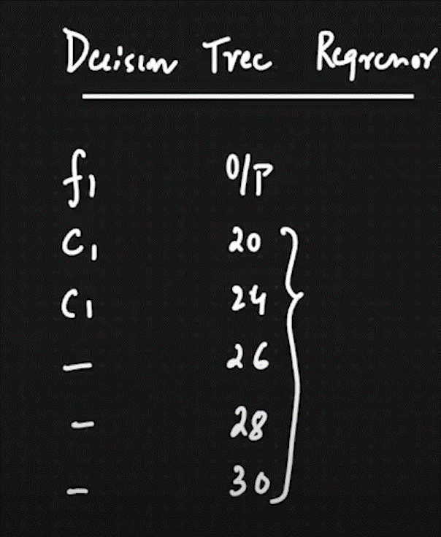

As you can see in this above picture there are features and columns are the as well as output is also there.

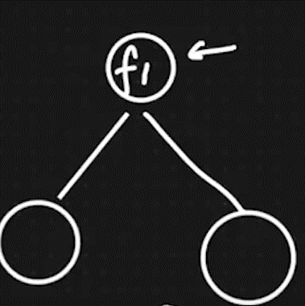

Consider that we have taken one feature F1 now to solve the problem of that to reach towards the leaf node first of all we will find the MEAN of the particular feature in this case we are finding with F1. Then we will add the category as child node.

Now from the category some data will be picked for C1 and some data will be picked for C2 then it will again find the MEAN and the it will find the means squared error.

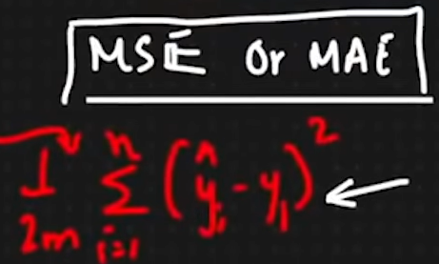

As shown above we are using this formula predicted – actual and then we are finding square of that afterwards we are doing summation with respect to m 🡪 total number of data and then 1/2m after the compute this formula we are finding the MSE or MAE (Mean squared error or Mean absolute error) then based on that we are adding more categories and then we are again calculating the mean of the category and MSE or MAE if we are getting the value near to 0 it means we are reaching towards the leaf node.

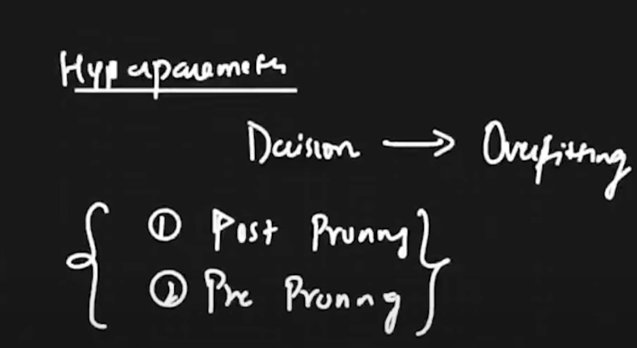

Hyperparameter for Decision tree regressor, it is leads to us the overfitting model where the training data is working properly with the model but with testing data it is not performing well. To get rid of this we are having post pruning and pre pruning.

Consider the below picture for post pruning

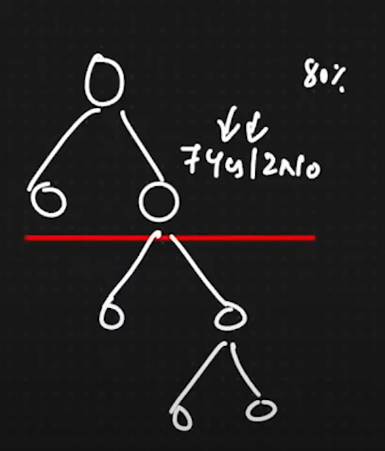

Post pruning: As you can see in above picture, we are having one large big tree and one of the columns is giving us 7yes and 2no it means 80% it will give us Yes now as we know that it is giving us yes most of the time then we don’t need to do further split we can just cut the below branches and we are not performing further splitting. This is we can called as Post pruning

Pre pruning: In this technique we are giving the max depth and max leaf node of particular decision tree and then we are restricting the depth and leaf nodes which will also help us to get rid of the problem of overfitting in decision tree regressor or classification.

**Bagging and Boosting**

**What is bagging?**

Bagging is the technique where we are having multiple models let us consider as we are solving classification model and then we are taking different model with different algorithm let us take 4 models 1st Naïve bay’se 2nd Decision tree 3rd logistic regression 4th knn classifier and let us consider we are having 1000 lines of testing data, now we are giving some lines of record to the individual model suppose we are giving first 200 lines to model 1 then we are giving another 200 lines to model 2 something like that we are giving different records to the different models and then we are checking the result of that and whatever the answer given by the all the models that will be consider as final answer. Example: Bootstrap aggregate bagging.

**What is boosting?**

Boosting is also one technique where we are having multiple models but they are weak learner (Not good predicters) and then we are passing our passing our model from each and every model so it will become one strong learner which will give us accurate prediction.

Let us elaborate more about bagging technique. Consider this picture.

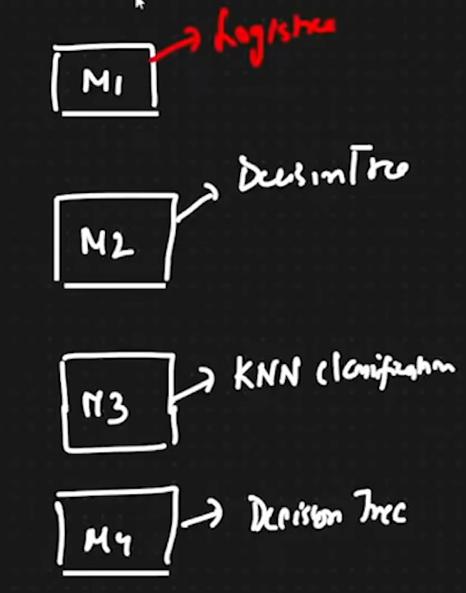

As we have discussed above we will be having multiple models of same problem statement (Classification or Regression) here we have taken four models first Logistic regression second Decision Tree classification third KNN classification fourth Decision Tree now we will perform further process on these models. 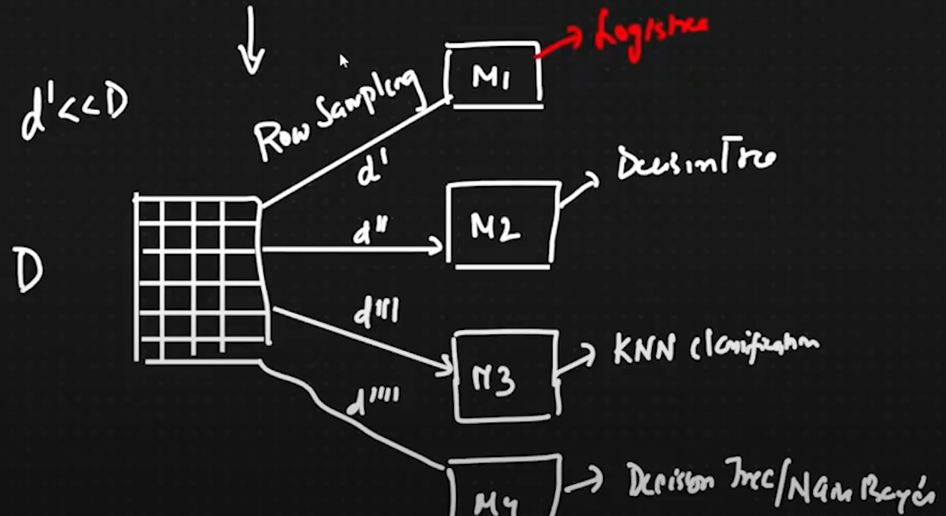

Consider this above picture here we are having on record D and then we are having our four models, now we will do row sampeling it means,

We will give some records to model 1 which is we can call as D dash, and we are giving another records to model 2 which is we can call as D2 dash and so on, (The records can be repeated while performing row sapmeling on different different model) Consider that D is always grater than D dash.

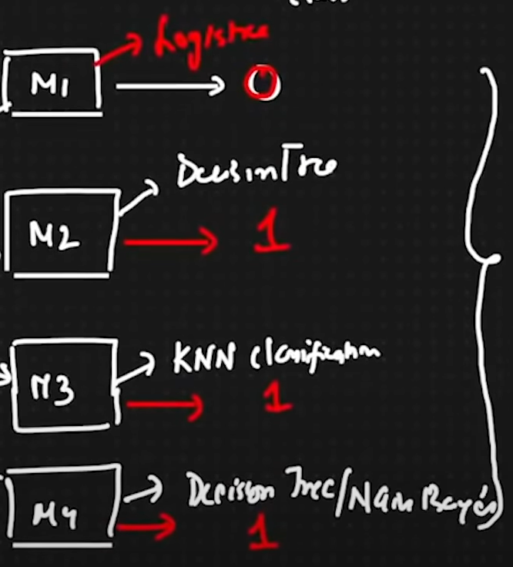

After performing the row sampling we will check the output, which model is giving which output as model 1 🡪 0 model 2🡪 1 model 3🡪 1

model 4🡪 now are we have discussed previously whatever the majority output given by the models that will be considered as our final output so in this case our final answer / output is 1.

Same with regression problem statement we will be having some values which will be given by our models. After getting the value from each model we will find the mean/Average of that and that will be our final output. (Note that we will always get majority voting there will be no tie in voting because we are using more than 100 or 200 models to perform this bagging technique)

**Boosting technique**

Let us consider this below picture to understand the boosting technique

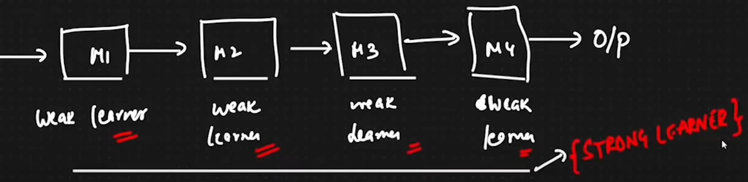

As shown above the models are connected linearly with each other where each and model is performing the problem statement on that with same algorithm. As model 1 is decision tree so the other models also will be decision tree.

These models are weak learners are they are not good at prediction and then we will pass our testing data to each and every model one by one means first we will give our data to model 1 then we will give another data to model 2 and so on. After that we will be getting one best accurate model as all the models are weak learners but after performing the prediction or testing the data on each and every model it will become strong learner which will give us accurate output. There are plenty of models which we will use in this boosting technique. Example of boosting is Adaboost, Xgboost etc.

**Random forest**

Random forest classification has classification part as well as the regression part where in random forest is used to get rid of the overfitting condition in decision tree algorithm random forest is the consist of decision trees where multiple decision trees will be taken to perform prediction and the majority output will be considered as final output in Classification and mean will be taken as final output in regression part of random forest.

Let us elaborate more about random forest, consider this below picture.

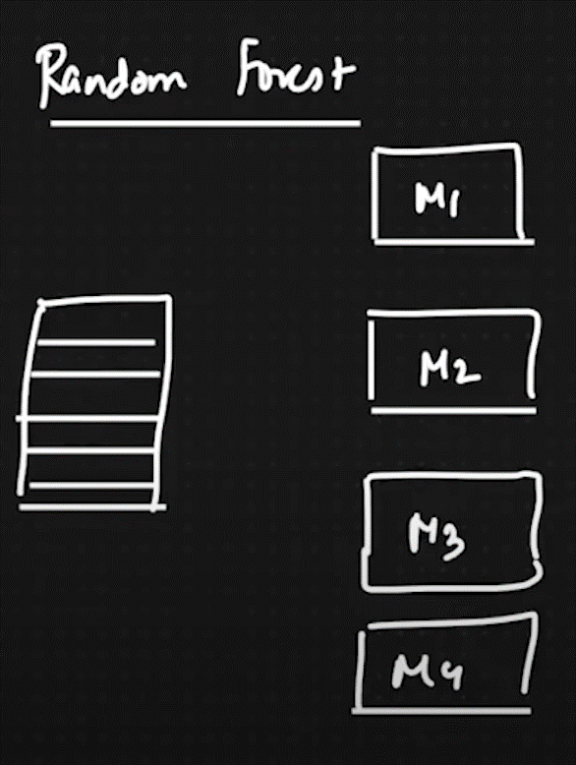

Consider above picture where we have taken one dataset which you can see in the picture like stack that is our dataset and other models are our decision tree models where we will apply row sampling, row sampling means where some features will be given to model 1 some rows and feature will be given to model 2 and so on. Note that while doing row sampling the features and the rows or records can be repeated.

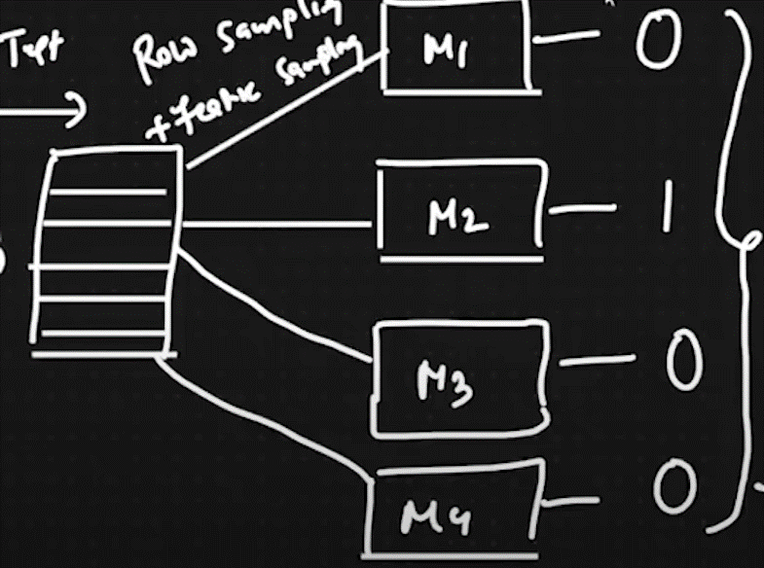

As shown in above picture, as we have done with our row sampling we will perform our execution of our decision tree models and as shown above let us consider that we have got another new test data, now based on that another test data our model 1 is predicting 0, model 2 is predicting 1, model 3 is predicting 0 and so on, later on the majority output will be taken and consider it as final output in this above case we have got the 0 majority of times so we will consider 0 as our final output of our new given testing data.

What is happening in random forest regression?

In random forest regression whatever the output we are getting from all the models we are finding mean/Average of that and then we are considering that answer as our final answer. Consider that above picture where assume that model 1 is giving us 100 model 2 is giving us 150 model 3 is giving us 170 model 4 is giving us 210 as an output so we are finding the mean of all these outputs and considering that particular final value as final output in regression.

**Adaboost Boosting technique**

Adaboost is the technique where we are using boosting technique in machine learning, as well as adaboost is mainly working on decision trees, these decision trees will be weak learners and after the formation of 100 or 200 weak learner we will get 1 strong learner which will predict accurately. Let us elaborate more about adaboost technique consider this below picture.

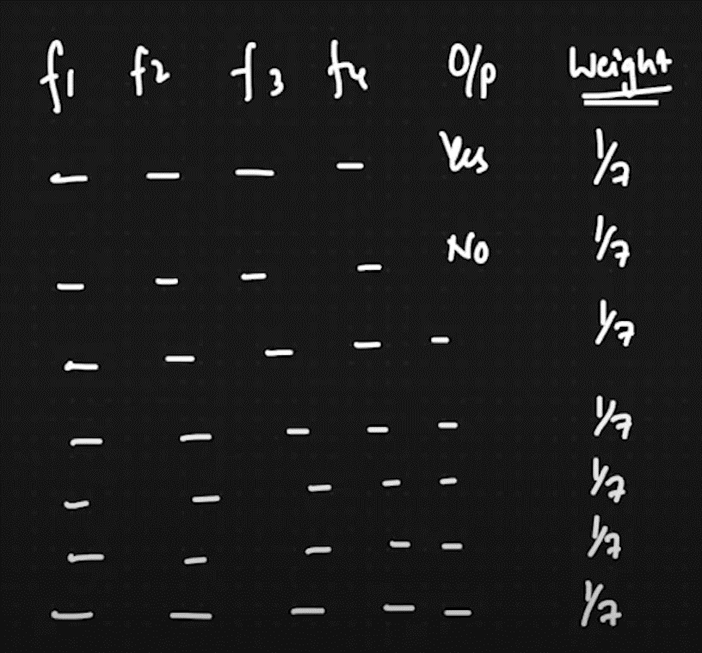

As shown in above picture we are having four features as well as we are trying to solve the classification problem, here is one new field which is weight, it should be between 0-1 always, here we are dividing the weights equally to each record in this above case we are having 7 records so we are giving 1/7 to each record note that after the summation of all the weights it should be 1. As we have given 1/7 to each record if we calculate the summation of all the records it will be 1. After that we will create decision tree, and we will find the best feature using entropy and information gain then we will do further steps, let us take F1 is the best feature.

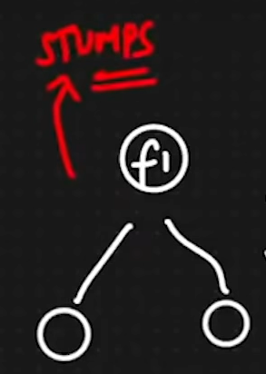

After we have considered F1 as the best feature, Now as we know that we are working on boosting technique, and we are using weak learners in our problem so as shown in above picture we took F1 feature, these weak learners decision trees depth or level will always be 1 as we are using weak learners so it should be depth of 1 decision tree all the time.

Now we will fit all the records to our F1 feature and then we will find how many of them are Correct and how many of them are incorrect.

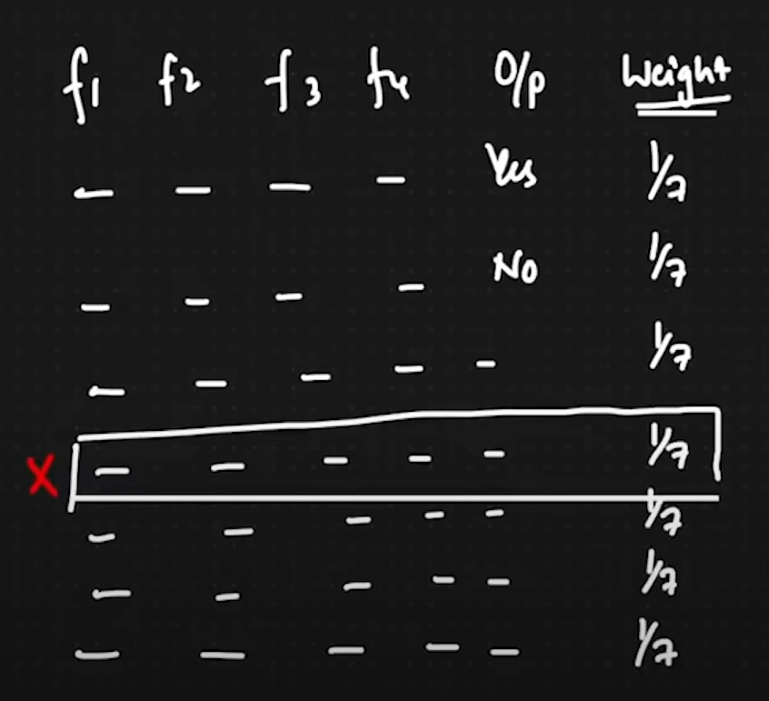

Now let us assume that from our 7 records the 6 are predicted as correct and 1 is precited as incorrect. After once we have found how many of them are correct and incorrect we need to update the weights of all the records.

Once we got the wrong error we need to find the total error in this above case out total error (TE) = 1/7

Once we found the total error of wrong record we need to find the performance of Stumps. (We can call 1 depth decision tree as stump).

Formula of performance of stump is given below.

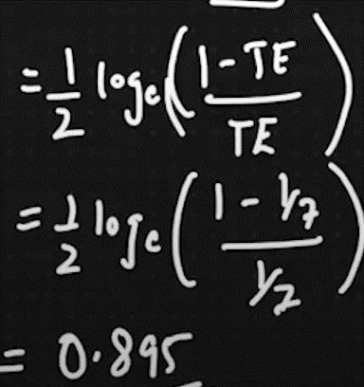

Now we are done with Total error and performance of stumps, now the next step is we need to update the weights of Correct records and incorrect records.

Formula to calculate the weight of correct record:

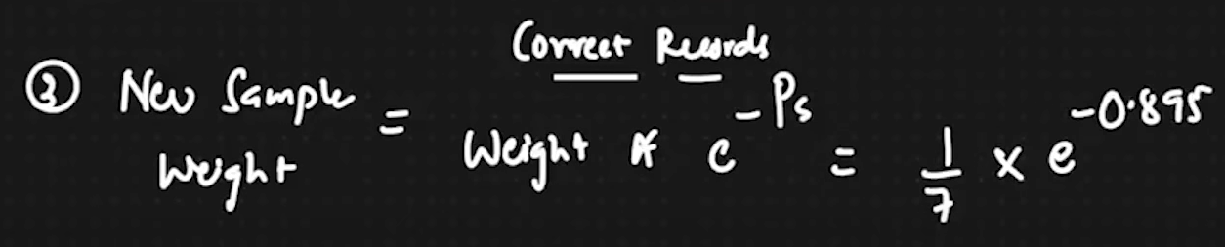

Formula to calculate the weight of incorrect record:

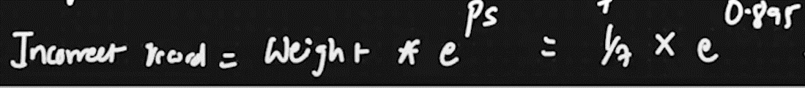

After applying the formula we got new weight 0.05 for correct records and 0.349 for incorrect record.

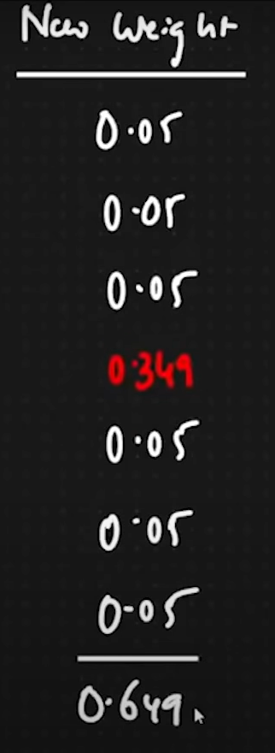

Now we got the new weights for all the records but as per our rule weights of all records should be 1 now if we calculate the summation of all the records it will not be 1. So for that we are adding all the new weights and we have got 0.649 once I have got this value, in all the case we need to follow this steps which we have learned so far. After getting the summation of all the new weights we need to divide the summation value with the each record’s new weight’s value. So it will be 0.05/0.649. for correct record and 0.349/0.649 for incorrect record. This process is called as normalization process, after that we will get the normalize values of all records. As shown below.

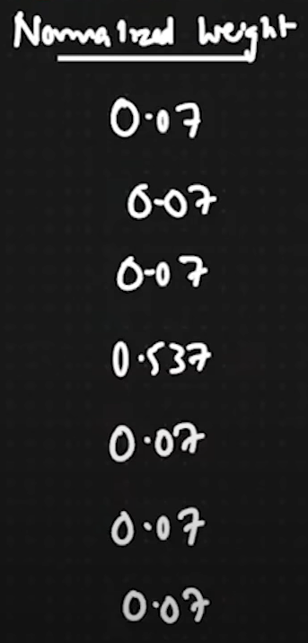

As you can see in above picture, all the correct records are having 0.07 value after the normalization. Incorrect record is having higher number which is 0.537. the reason of doing this normalization is to send the incorrect records to the next weak learner then it will repeat the entire process and again that weak learner will send other incorrect records to the next weak learner and this is how we will get the strong learner.

Now to find out how many of them will go to the next weak learner we are applying something called as buckets.

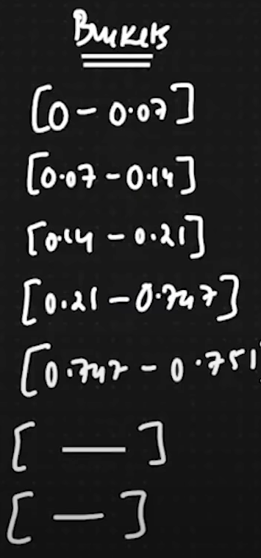

Buckets we are using to find our whether which record will go to the next weak learner or not. To do that next weak learner will generate the random number between 0 to 1 and we will keep on adding the weights, as shown above 0 then 0.07 is added in next line 0.07 – 0.14 again 0.07 is added each and every time the weight will be added to the previous weight and as you can see 0.21 – 0.747 that is the biggest bucket we have ever got in these records, the main reason is to perform buckets because the less value’s records will be considered as correct and the remaining once who has higher bucket difference will go to the next weak learner.

This process will be continued with different values and then again it will do all the process and incorrect records will be sent to the next weak learner and so on after all these things we will get one strong learner which will be our accurate predicter.

**Black box models VS White box models**

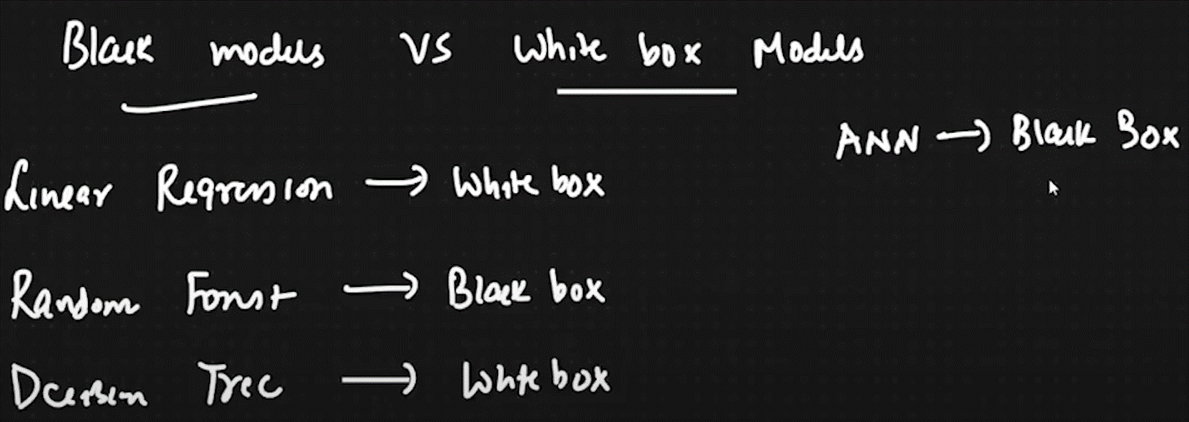

Black box models: These models are complex and we cannot compute the maths by human hands, there is so much complexity and we cannot perform that particular algorithm manually.

White box models: These models are not complex and we can compute the maths by human hands, there is less complexity and we can perform that particular algorithm manually.

Examples are given in above picture.